MMT Policymaking Praxis and Financial and Economic Stability: A Response to Critiques
Eric Tymoigne
Lewis & Clark College

Beyond the political instability that that is supposed to come from applying MMT to policymaking, a group of critiques argues that MMT also promotes economic and financial instability. In terms of economic instability, MMT policymaking is supposed to promote large increases in government spending and large increases in deficits, first and foremost to reach and maintain full employment (Sawyer 2003). In addition, MMT is also supposed to imply that taxes and government securities are irrelevant, at least below full employment, so the money supply grows without limit, which will lead to hyperinflation and major dislocations in the economy (Bossone 2021; Kotlikoff 2021). As such, as Rogoff (2019) put it, MMT “is just nuts” and a bunch of “nonsense” that will lead to disasters if applied to policymaking (Summers 2019).
A second group of critiques notes that MMT policymaking promotes financial instability through two channels. One is loose fiscal policy and the other is a zero-interest rate policy (ZIRP). On the fiscal side, with permanent deficits assumed core element of MMT policymaking, “each subsequent issuance of debt would add to the stock of debt outstanding and inevitably depress its price, all else equal.” (Bossone 2021, 160). This is the well-known crowding out effect, which raises the financial fragility of the economy as debt service growth rises while income growth slows. As such, MMT is only reserves for situations when the economy is in a liquidity trap or, more broadly, when interest rates are low (Krugman 2011). The destabilizing impact of the crowding effect is supposed to be aggravated by the increase in tax rates that will be needed at some point to repay the public debt. On the monetary side, a ZIRP is argued to promote overindebtedness and speculative bubbles (Epstein 2019). As Palley (2015, 18) put it “this interest rate policy passivity is tantamount to believing that financial markets are stable and set interest rates and asset prices appropriately”.
A third group of critique focuses on external instability. Some critiques argue that MMT policymaking can mostly, if not only, be applied to the United States because it is a closed economy and the US dollar (USD) is the currency of the world. That means that the United States is not subject to a balance of payment constraint and can run trade deficits without running the risk of depreciation of its currency. Any other country that decides to implement discretionary fiscal policy will record a permanent increase in its trade deficit, which is not sustainable because this will rapidly deplete the foreign reserves required to service foreign debts and to import crucial consumption, intermediary and capital goods (Vernengo and Caldentey 2020). In addition, a persistent trade deficit will lead to a depreciation of the currency, which, in developing economies heavily reliant on imports, will translate into inflation and lower real wages. As such, letting the currency float is not a viable option and so monetary sovereignty is not achievable or of limited use.
MMT and Economic Stability: Government as a stabilizing and stimulating force.
Fiscal deficits stabilize economic activity and promote financial stability
A first channel through which MMT is supposed to promote instability is through a bias toward loose fiscal policy. The first problem with this view is that it mischaracterizes the MMT position; MMT does not advocate out of control government spending and does not view the fiscal balance as a proper policy goal. The second problem is that this view misunderstands the impact of fiscal deficits on economic stability. Fiscal deficits are a boost to the saving level of the domestic private sector, state and local governments, and the rest of the world. Fiscal deficits sustain national income by injecting more income in the economy than they remove through taxes, which improves the liquidity and solvency of other sectors. Fiscal deficits sustain private investment by stabilizing expected sales—the main driver of business investment—while having a negligible impact on interest rates (that are not a key determinant of business investment). As Minsky noted, a “big bank” (a central bank that provides an elastic currency by stabilizing interest rates and acting as lender of last resort) and a “big government” (a Treasury that spends and taxes enough to smooth national income throughout the business cycle) are central to financial stability. Economic growth, therefore, will not generate a weakening of the financial positions of private units if it is based on federal/national government programs that continuously sustain the private sector’s surplus and inject safe assets into the balance sheets of private units, although that might be inflationary (Minsky 1963, 1993). Fiscal deficits tame financial crises, they do not lead to financial crises when monetary sovereignty prevails because government is always solvent in its own currency and because private income is sustained. Put in Minskian terms, a monetarily sovereign government is always in a hedge-finance position regardless of its fiscal balance or the size of its public debt as long as it only issues debt denominated in the domestic currency.
In addition to stabilizing national income, fiscal deficits also have beneficial portfolio effects for other sectors of the economy. Deficits translate into the public debt and Treasuries are credit-risk free (the nominal debt service can always be paid on time in full), highly liquid financial instruments that are a core staple of the financial system. Treasury securities provide the non-federal sector with a way to allocate its financial net wealth in a safe way; they are also safe collateral and are a core means of meeting the requirements of financial regulations. In the United States, U.S. Treasuries represented a high proportion the balance sheet of banks after World War 2, which helps explain why the war was followed by decades of financial stability (Minsky 1983).
Recently, Reinhart and Rogoff (2009) studied the impact of the public debt on economic stability while they noted in passing the importance of private debt. The main issue with their book is not a technical error that invalidates their result but rather a theoretical one (Nersisyan and Wray 2010). They see a fiscal deficit as a source of instability independently of the nature of the monetary system in place. The hidden premise is that a fiscal deficit is a source of financial problems under any condition. However, a typical result found of the early warning system literature is that fiscal surpluses are a leading indicator of currency crises:
This counter-intuitive result is now well documented in the literature: many of the countries hit by a crisis actually ran a fiscal surplus, noticeably Mexico in 1994 and the Asian countries in 1997. This fact led many authors to reject first generation models of currency crises for more elaborate models in which moral hazard plays a role (a country with a government surplus is more likely to bail out risky investment projects). (Bussière and Fratzscher 2002: 27)
The fact that fiscal surpluses are associated with crises is easily understandable if one accounts for national accounting relationships and the monetary relations they imply. It is not an issue of moral hazard due to bail outs but rather that fiscal surpluses drain income out of the non-federal sector, which leads to problems for the non-federal sector in meeting its nominal debt commitments and generates a need to refinance. When this involves foreign-currency denominated financial transactions, any refinancing problem is prone to generating a currency crisis and a banking crisis (Kregel 1998).
The stabilizing effect of fiscal deficits can be seen in Figure 1. By letting the fiscal balance accommodate the needs of the economic system through the establishment of automatic stabilizers and by quintupling its average share of spending in the economy compared to the 1880-1939 period, the federal government has considerably contributed to the stabilization of the economy post WWII (Minsky 1986a; Taylor et al. 2012; Hein 2018; Cohen and Follette 2000). Since the end of 1930s, contractions in the United States have been much milder, much less lengthy, and much less frequent. Similar trends are observed throughout the developed world, although the return of “free-market” thinking over the past 40 years has increased in financial instability (Bordo et al. 2001).

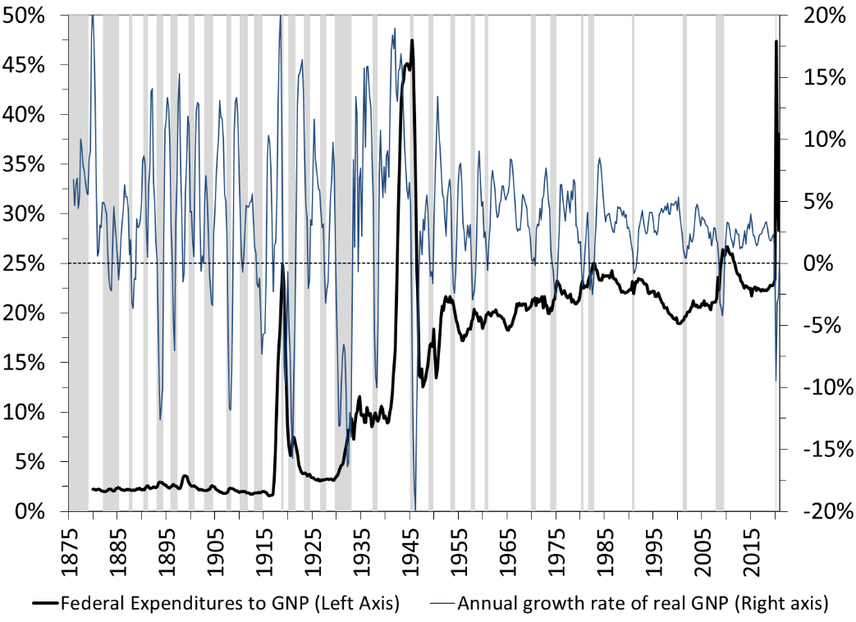
 | Size of Federal Spending (% GNP) | Number of contractions | Average Frequency (Years) | Average Length (Months) | Average Value of Declines in Real GNP | Average Growth Rate of Real GNP | Average St. Dev. of Real GNP
1880-1939 | 4.2 | 16 | 3.8 | 21.8 | -5.82% | 3.15% | 7.47%
1947-2021 | 21.3 | 12 | 6.3 | 11.1 | -1.94% | 3.07% | 2.71%
Figure 1. The U.S. Business Cycle: 1875:1-2021:1 (Base: 2012)
Sources: National Bureau of Economic Research, Bureau of Economic Analysis, Gordon (1986).

The third problem with the idea that fiscal deficits are destabilizing is that there is a weak relationship between the fiscal balance and interest rates. One may as well assume that that there is no relation between the two variables. Fiscal deficits do not raise interest rates; fiscal surpluses do not lower them. Figures 2 and 3 show that in the United States interest rates are not driven by the fiscal balance of the U.S. Treasury, they are driven by the monetary policy of the Federal Reserve (Akram and Li 2017; Atesoglu 2003, 2005). When a national Treasury runs large deficits, it usually does so during a recession when tax revenues plummet. During a recession, the central bank also lowers its policy rates to help the economy and all other interest rates tend to follow and to stay low. During World War 2, when the fiscal deficit ran past 20 percent of GDP as government spending increased very rapidly, the Federal Reserve set all interest rates on the US public debt very low for years and private interest rates followed and stayed low for years. During the early-2020s COVID-19 pandemic, the same occurred and similar lessons can be drawn for other countries (Borio et al. 2017; Sharpe 2013; Akram and Al-Helal Uddin 2021; Akram 2021).
As the economy recovers and expands, central banks tend to raise their policy rates and other rates follow, but this does not mean that fiscal deficits are unsustainable. First, while fiscal deficits are a stylized fact they are not unresponsive to what happens in the rest of the economy and tend to fall so the growth of public debt slows. Second, as long as the nominal cost of the public debt (i) stays low relative to the nominal growth of the economy (g), the public debt will not explode relative to the size of the economy. Usually the interest rate on the public debt is below the growth rate of the economy. While the mainstream has finally recognized this stylized fact, after assuming that the opposite is usually the case in their economic models (Blanchard 2019), MMT goes further by explaining this stylized fact. A monetarily sovereign government has control over the nominal cost of the public debt because the interest rate on the public debt is a policy variable, that is, the interest rate on the public debt is overwhelmingly influenced by monetary policy (Fullwiler 2006, 2020; Aspromourgos et al. 2009). This is true regardless of the proportion of public debt held by the foreign sector. The control is complete for the interest rate on T-bills and very strong for the rates on T-notes and T-bonds. Thus, a rapidly growing public debt does not necessarily translate into an increase in the share of interest payments in government spending if the central bank simultaneously lowers its policy-rate target (Figure 4). This is all the more true that in time of national emergencies, when discretionary spending rises quickly and so interest payments represent a lower share of the overall budget. For example, during World War 2, the share of interest expenses in government spending fell to a historical low of 5 percent while the public debt reached a historical high of almost 120 percent of GDP. After the war, the public debt fell relative to the size of the economy but the share of interest payments grew to reach 20 percent as interest rates on the public debt grew with the rise in the federal funds rate (FFR). The Covid-19 pandemic has generated dynamics similar to those during World War 2.
Fourth, one must come to recognize that the public debt will never be repaid and that a higher public debt will not translate in higher tax rates that will squeeze private income. There is no reason to pay it back, and doing so would be harmful to the finances of the non-federal sector for the reasons provided above. We have not been burdened with higher tax rates to repay the public debt created at the time of our grandparents; our children and grandchildren will not be burdened with higher tax rates to repay the public debt created today. This does not mean that taxes are not needed when monetary sovereignty prevails; they are, not only to create a demand for the domestic currency but also for other purposes (Ruml 1946). In addition, policymakers may decide to raise tax rates in the future but this ought not to be justified by the goal of repaying the public debt. The public debt will keep piling up to accommodate the needs of our growing economy for a safe asset and the government’s ability to keep paying it on time will persist as long as it is monetarily sovereign.

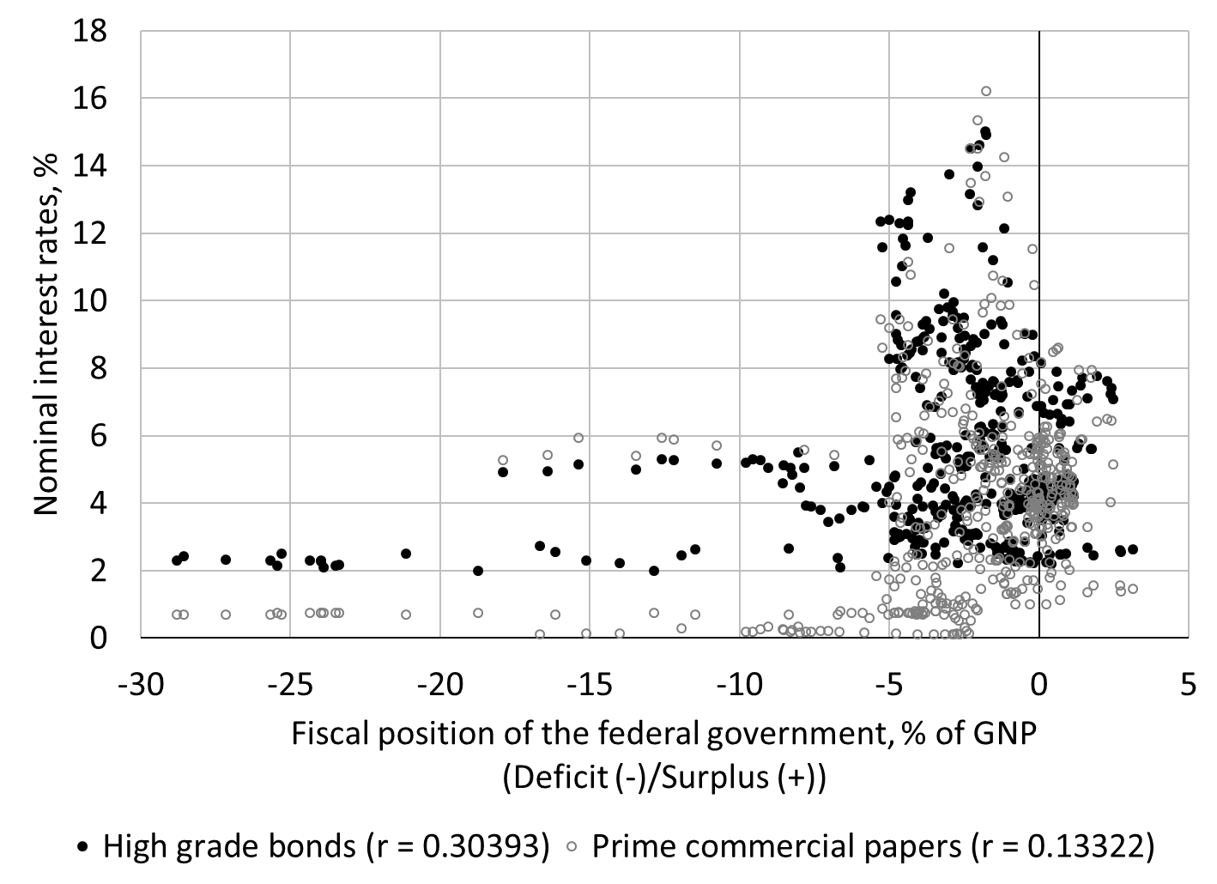
Figure 2. Fiscal position and interest rates, Q1 1900 to Q1 2021.
Sources: Treasury Bulletin, National Bureau of Economic Research, Monthly Receipts, Outlays, and Deficit or Surplus, Fiscal Years 1981-2017.

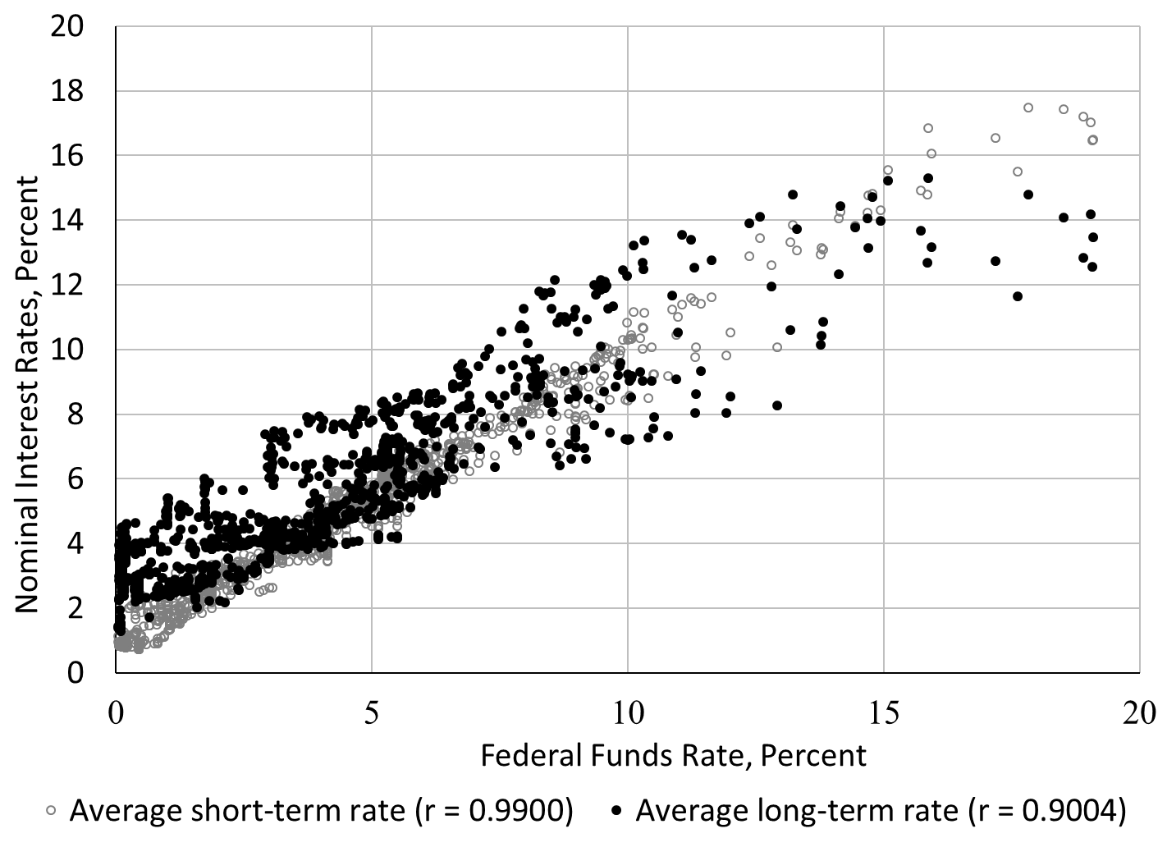
Figure 3. Monetary policy and interest rates, January 1919 to June 2021
Sources: National Bureau of Economic Research (Macrohistory Database), FRED.

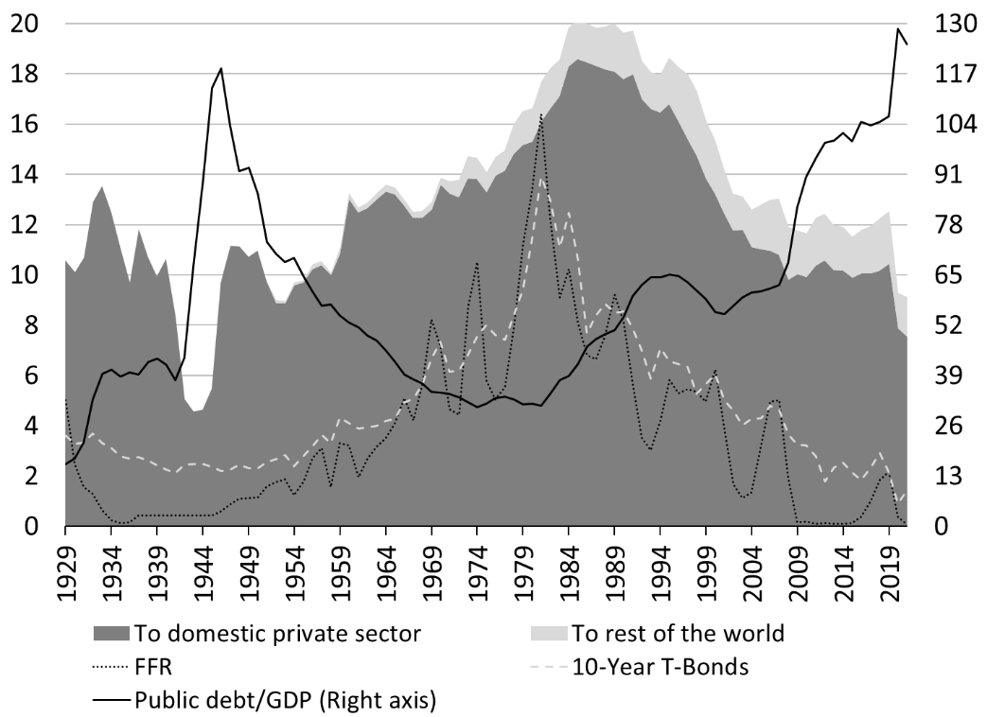
Figure 4. Share of interest payments on the public debt relative to total government spending (Shaded areas), public debt and interest rates. Percent.

Investment-led growth policies are destabilizing
The fifth issue with the view that fiscal deficits are destabilizing is that investment-led growth is not sustainable and destabilizing, and that government plays a major role in countering the stagnating and destabilizing impacts of such source of growth. Domar (1946) extends Keynes’s static approach to the problem of economic growth and shows that investment-led growth is unsustainable because the level of net investment grows productive capacities while aggregate demand only grows by a multiple of the change (not level) in investment. The issue is not solved by allowing substitution effects à la Solow to take place through changes in relative input prices as the Cambridge Controversy concluded (Lavoie 2008). Minsky complements Domar by showing that reaching financially sustainable long-term full employment and price stability cannot be based on promoting the growth of private investment. Minsky (1973, 1981, 1986a) also notes that the emphasis on investment creates inflationary pressures and income inequality. Steindl (1952), Walker and Vatter (1989) and Vatter et al. (1995) build on Harrod’s, Domar’s and Minsky’s analysis by showing that the main constraint on economic growth has been an insufficient growth in aggregate demand not an insufficient growth in aggregate supply (Wray 2008). They conclude that the government has a crucial role government to play, not only in stabilizing the economy, but also in putting it onto a higher growth path.
The mistaken emphasis upon physical capital· accumulation reveals […] a defect in the ruling growth models to which we have called attention: they are essentially laissez faire constructs. Acknowledgement of the long-established presence of big government is considered ancillary to long-run growth analysis. Government is allowed to intrude mainly and merely into such matters as subsidization of sectors, regulation, research, and education of the labor force. Big government as the decisive, dynamic, autonomous source of demand growth, historically coming to replace private fixed investment is, like the demand side in general, omitted from the usual model. (Walker and Vatter 1989, 344-345)
Contrary to the loanable funds approach (in which government competes for resources with private investors) and the efficient market framework (in which government intervention leads to misallocations and stifle innovations), government spending has been a necessary and complementary component to economic growth and a major source of innovations that may stimulate both public and private investment (Mazzucato 2015).
Achieving full employment without stimulating aggregate demand
Another way through MMT fiscal policy recommendations promotes full employment and price stability is by not relying on the continuous stimulation of aggregate spending to achieve full employment. There are two aspects to this method of achieving full employment. The first aspect is that the Job Guarantee program (JG) achieves full employment for any level of aggregate demand by de facto removing the chronic gap between the number of unemployed and the number of job openings (Mitchell and Wray 2005). Initially, economic activity would be stimulated by the implementation of the JG because of the multiplier effect on employment and income in the private sector and because, for MMT proponents, the JG would pay a living wage that is higher than what the unemployed receive through unemployment insurance and welfare. The ultimate effect on inflation would depend on the overall impact of JG on spending and production. Wray et al. (2018) and Fullwiler (2007) show that the overall impact on inflation will mostly be marginal and transitory. The unemployed already impact aggregate demand, capitalist economies suffer from a chronic lack of demand and productive capacities can usually adapt to permanent increases in demand. The JG would also dampen inflationary and deflationary pressures throughout the cycle through countercyclical movements of the JG pool; thereby making the fiscal balance more countercyclical. A second aspect of this method of achieving full employment is how it deals with bottlenecks by redistributing government spending instead of applying a stop-go policy. As Keynes noted in 1937, the United Kingdom was no longer in need of an overall boost in aggregate demand but rather in need of a “rightly distributed” demand. The JG is a targeted spending policy not an overall spending policy; it raises government spending in areas where full employment has not been reached and stops government spending automatically otherwise (as there is no additional person seeking a job). For areas where full employment has been reached and the private demand for workers is still strong, private businesses can draw from the JG pool and so government spending falls. The net impact on overall government spending is undetermined, but what matters is that it has been redistributed toward localities that need it and away from areas that do not. This flattens the area of the aggregate supply curve where “semi inflation” occurs.
For the last resort use of monetary policy
The second channel through which financial instability is supposed to occur is through permanent zero-interest-rate policy (ZIRP) or, more loosely, the last-resort use of interest rates to manage economic activity and inflation. MMT supports a default ZIRP and argues that monetary policy is not a reliable tool for fighting inflation because of its weak and potentially perverse effects (Mitchell and Muysken 2008, 146ff.; Papadimitriou and Wray 1994, 1996). While some areas, such as housing, are more sensitive to changes in interest rates, overall interest rates do not play a major role in determining spending, especially business investment (Fazzari et al. 1988; Fazzari 1993; Glyn 1997). This sensitivity declines as an economic expansion progresses and is even lower now that gradualism and transparency have made it much easier for economic units to anticipate adverse changes in interest rates and to hedge against them.
Another problem with the use of monetary policy to fine tune the economy is that it presupposes an inverse relationship between demand for credit and interest rates. However, in a leveraged economy, economic units have to meet their financial commitments regardless the level of interest rates and higher interest rates mean higher financial commitments, which creates a potential need to ask for more credit to meet these commitments (Wray 1993; Mason and Jayadev 2014). Thus, an aggressive monetary policy to fight inflation may promote financial instability when a large proportion of refinancing operations is needed to sustain economic activity (Kregel 1992).
Finally, interest rates may have a perverse effect on inflation through cost and demand channels. Higher interest rates raise operating costs and businesses may pass those costs onto their customers. Higher policy rates also boosts the income of rentiers and raise their consumption (Lavoie 1995; Kelton and Wray 2006; Tauheed and Wray 2006; Tillman 2008). Chairman Greenspan (Federal Open Market Committee 2000, 85), among others at the FOMC, recognized this possibility: “There is deterioration in the inflation rate stemming from interest costs and energy costs, and those are not trivial sources of deterioration. At the end of the day it doesn’t have to be labor costs that are causing the overall inflation deterioration.”
Overall, the emphasis on an inverse relationship between interest rate and spending is unwarranted and MMT does not view monetary policy as a relevant tool to fight inflation. While a lot of credit is given to an improvement in monetary-policy management for the price stability observed from the mid 1980s to the mid 2000s (Bernanke 2004), monetary policy played a minor role as Governor Teeters (Federal Open Market Committee 1981, 46) noted already in 1981:
May I remind you that we shouldn’t take too much credit for the price easing? I never thought we were totally at fault for the price increases that we suffered from OPEC and food; and I don’t think the fact that OPEC and food have calmed down has a great deal to do with monetary policy per se, except in the very long run.
Most of the credit for price stability should be attributed to the taming of energy prices and the industrialization of China that flooded the world with cheap goods, together with a bit of luck (Stock and Watson 2002, 2005).
For all the previous reasons, a ZIRP is MMT’s preferred monetary-policy option. Instead the central bank should refocus its operations and goals on the purpose for which many central banks were created (Capie et al. 1994), namely ensuring an elastic currency for the economy (i.e. reliable financing and refinancing channels for banks and the national government) together with proactive regulation and supervision of the financial industry. MMT proponents advocate financial regulation and supervision along the line of Minsky’s theoretical framework, which recognizes the inherent instability of capitalist economies (Tymoigne 2011). Government has a role to play through the promotion of safe underwriting (promote hedge financing), the establishment of a banking structure that promotes long-term recurring relationships between bankers and their debtors, and the regulation of financial innovations toward safe financial products. Bank credit should be limited to creditworthy borrowers but banks should be encouraged to look for them wherever they are and to avoid redlining (Minsky et al. 1993). Creditworthiness is defined here differently from the way bankers use it. MMT advocates that banks should analyze the means used to service debts (“How will you repay on time?”) in addition to willingness and ability to pay on time (“Will you repay on time?”) (Tymoigne and Wray 2014). Credit controls can be useful for restricting the flow of credit to speculative endeavors and moving it toward financially sustainable economic activities that are defined as “good” by the public purpose. The central bank can play its part by discounting some financial assets while refusing others.

MMT policymaking praxis and the rest of the world
Use domestic policy levers to employ domestic resources
MMT starts from the basic principle layout by Keynes in 1940:
A government which has control over the banking and currency system can always find the cash to pay for its purchases of home produced goods (Keynes 1940 [1972], 416).
Monetary sovereignty can most effectively be used by a government to ensure the full employment of domestic resources for the fulfillment of unmet domestic needs. Unused labor hours are usually plentiful and they can be harnessed to provide goods and services to the segments of the population (some of them JG participants) that are not serviced by other sectors of the economy because of their inability to pay or because other sectors are not doing enough. Depending on the availability of non-labor resources, the ability to achieve the full employment of labor may be difficult and so a policy like the JG may have to be limited in scope (Wray 2007). In addition, government policies such as the JG can be used to lower progressively the dependence on some of the critical imports by using labor and other domestic resources to produce them. Once again, government policies have to be designed in a way consistent with the level and structure of resource constraints with the purpose of fulfilling whatever the public purpose is.
Fiscal deficits are normal and accommodative
While implementing policies to use domestic resources, the fiscal position usually will be in deficit and move countercyclically. The United States is special in the sense that the US dollar plays a central role in the international monetary system. This means that foreigners desire to accumulate US dollars and so the fiscal deficit must be larger than it would otherwise have been (Minsky 1986b). If the rest of the world thinks the net financial accumulation of USD is too large, the only ways foreigners can reduce it is by buying more goods and services from US sectors (US exports rise), cutting sales of goods of services to US sectors (US imports fall), reducing their reliance on USD-denominated incomes and transfers, selling USD to US sectors for foreign currency, and/or repaying debt owed to US sectors. All of these may have an impact on the exchange rate but it depends on the pace of change and the ability of quantity adjustments to accommodate the change in desires to hold the US currency. The fiscal balance of the US government would move to a surplus if the foreign sector wanted to record a large enough current account deficit with the United States (Wray 2019). Once again, the fiscal balance is the relief valve that performs at least some of the adjustment.
A few countries, mostly in Scandinavia recently, have been able to record simultaneously a fiscal surplus, a domestic private surplus and current account surplus (the foreign sector is in deficit). It may be tempting to view this as an “ideal” economic outcome because of the association of surplus with soundness (e.g., Bloomberg Editorial Board 2012). However, not only are those accounting balances not appropriate policy goals, but also trade deficits provide real benefits to the domestic population (Wray 2015). As such, policymakers should focus on existing resource and political constraints and adjust their policy accordingly, knowing that they have no control over the final fiscal outcomes. In addition, the “ideal” economic outcome relies on the willingness of the foreign sector to run deficits; something over which domestic policymakers have absolutely no influence. The usual/normal economic outcome is for a country to run a fiscal deficit while the current account can be chronically in deficit, chronically in surplus or changes sign overtime.
Current account balance and exchange rate
Two common criticisms of MMT are that large current account deficits are not sustainable and that chronic current account deficits depreciate the currency. The first criticism is based on the false premises that MMT wants to implement policies that increase and sustain large fiscal deficits, which in turn will result in a large and sustained current account deficits. MMT does not propose to put in place policies with a specific fiscal balance, and does not inherently aim at a major and sustained increase in government spending. In addition, the causality behind the twin-deficit story is incorrect, because it is the foreign sector that decides how much of the domestic currency it wants to accumulate. The fiscal position is mostly the one adjusting to that desire and the desire of the domestic private sector and so there is not a one-to-one relation between the foreign and fiscal balances (Ali Abbas et al. 2010). In addition, overtime the size and sign of the current account balance may change but some countries, given their economic structure and international conditions, must usually record a chronic current account deficit or a chronic current account surplus.
This leads to the second criticism that a current account deficit leads to a depreciation of the currency. The adverse impact of current account deficit on the foreign exchange rate is not supported by the data for developed economies (Harvey 1991, 2019). As noted at the beginning, it is also well established by the early warning system literature that fiscal surpluses are associated with currency crises. Foreign exchange rates are mostly determined by portfolio arbitrages instead of trade flows and their determination follows the same logic as the theory of asset prices put forward by Keynes, with central banks still having the ability to influence interest rates even in an open economy (Lavoie 2000). While the relation between trade flow and exchange rate movements may be stronger for developing and open economies for which the foreign sector does not desire to hold the currency, the direct association of trade flows and exchange-rate movements is unwarranted in the same way it is unwarranted to make a direct connection between the fiscal balance and price dynamics. Figure 5 shows that, for the United States, there is no relationship between the trade balance and exchange-rate movements. The same applies to Mexico (Figure 6).

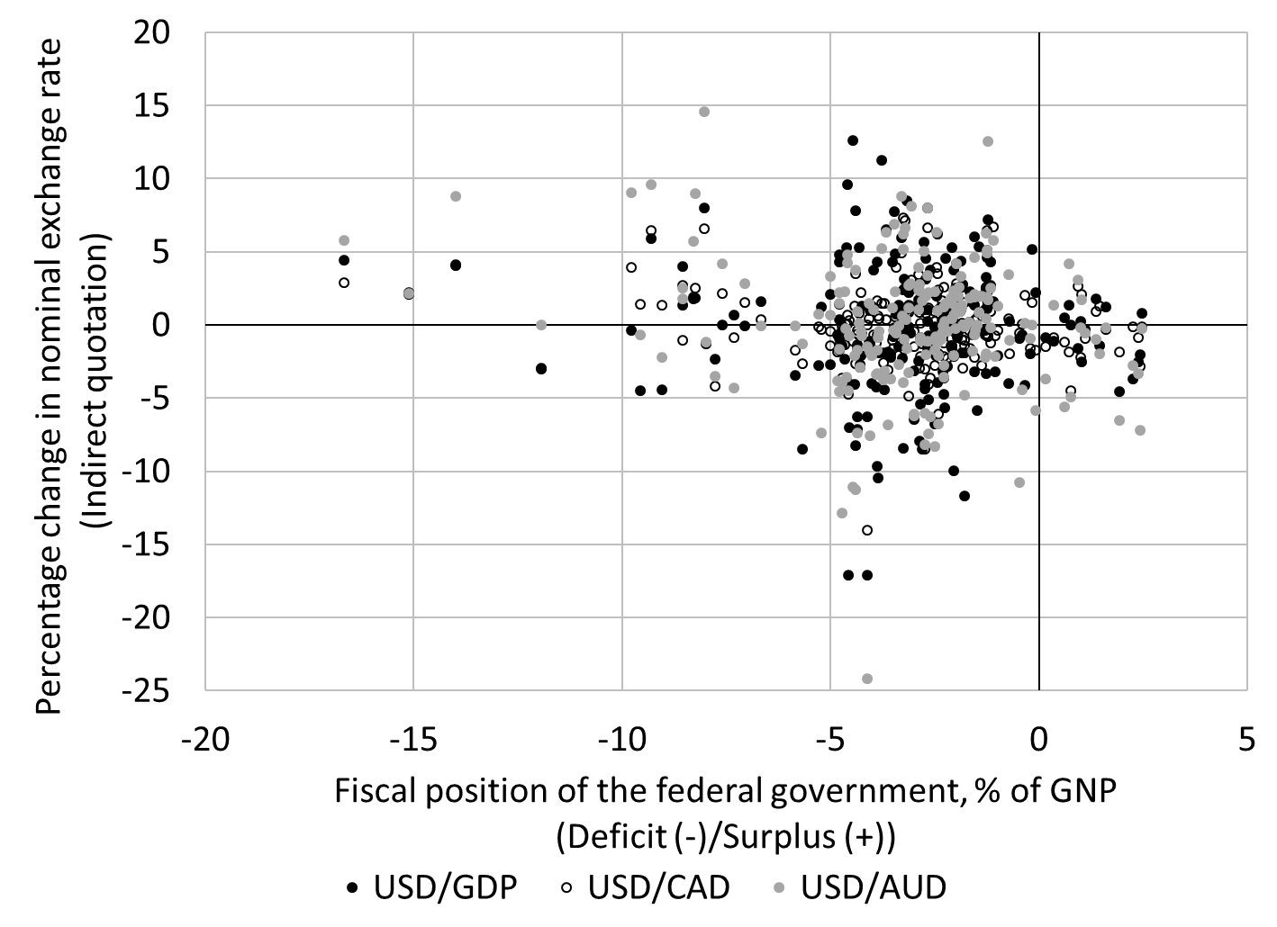
Figure 5. Fiscal position and the exchange rate in the United States, 1971 Q1 to 2021 Q1
Source: Board of Governors of Federal Reserve System (H.10 series) and Figure 2

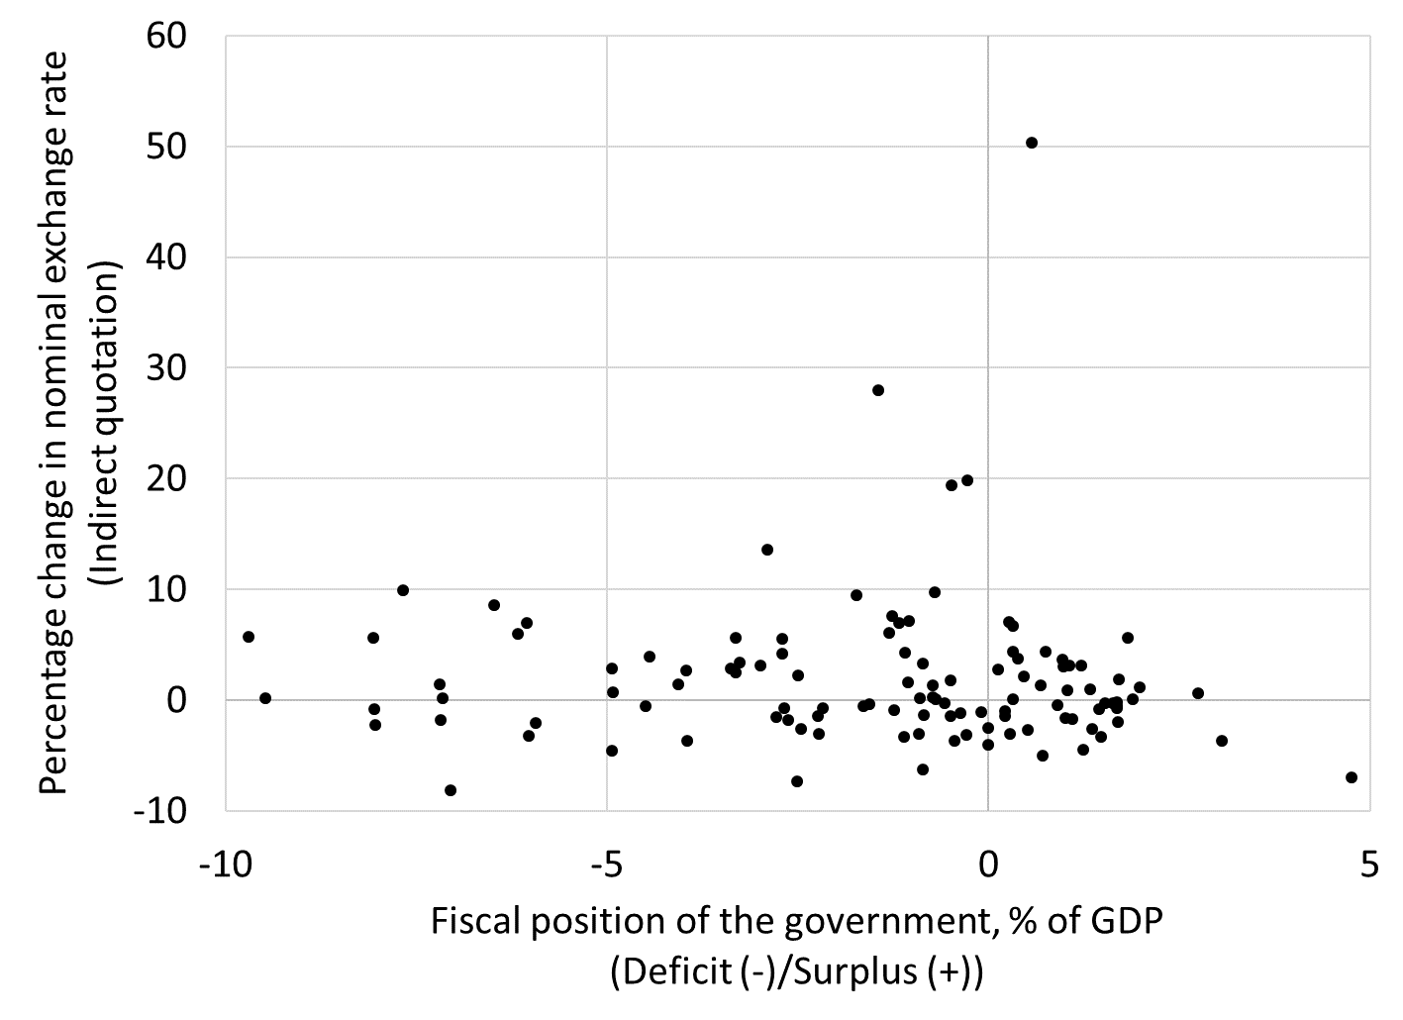
Figure 6. Mexican government fiscal position and the dollar-peso exchange rate, 1993 Q1 to 2021 Q2
Sources: Organisation for Economic Co-operation and Development, Bank of Mexico.

Accounting for potential challenges while emphasizing the use of domestic resources
That being said, there are five issues that need to be managed when dealing with foreign transactions. First, pass-through inflation that comes from the rising cost of imports following a depreciation is a relevant concern. Second, the balance-sheet impact of depreciations when debts denominated in a foreign currency are present is also a concern. Third, the possibility that foreign reserves dwindle and prevent foreign debt servicing and the purchase of imports is also a concern. Fourth, some countries are highly dependent on food and energy imports and/or cannot develop on their own. Fifth, if there is no internal desire to accumulate the domestic currency, the ability of the government to spend without disrupting domestic prices will be limited. MMT proponents have long recognized these problems but, instead of giving up to the neoliberal policy agenda, they have embraced policies that work around these problems in order to give priority to full employment (Mitchell 2000; Wray 2007; Kaboub 2012; Kaboub and Aliriza 2019; Sylla 2020)
MMT proposes to mitigate these potential sources of instability by using, among others, import substitution policies and payment in kind for JG production to limit the ability of the domestic private sector to purchase imports. Second, MMT advises against the issuance of foreign-denominated public debt because there are no clear international bankruptcy procedures for default on such public debt. Third, to ensure that foreign reserves are generated, an export base should be developed. An international buffer-stock policy for raw materials also ought to be promoted to stabilize the commodity prices of developing economies that depend on exporting them for development. However, international long-term financial help through public institutions also ought to be promoted because the reliance on private finance for development is prone to Ponzi finance (Kregel 2004). Capital controls can also be an option if politically and technically possible. Fourth, policies should be put in place to limit tax evasion and increase the size of the formal sector in order to increase the demand for the domestic currency and so widen the policy space of the government.
Finally, some countries are in very dire straits with limited arable land, a majority of low-skilled self-employed individuals, a large informal economy, a high dependence on food and energy imports, and poor political stability. Such a country cannot develop on its own and needs international help but that help should be inclusive of the desire and needs of the local population. Other countries may be not be in such a bad economic situation but are still dependent on international help for development. The JG can be used to reduce that dependency but international aid is needed to provide financial and physical resources, to sustain the local currency if it is used in international markets to import, or to provide grants to obtain the foreign exchange needed to buy imports.
Promoting a one-size-fit-all policy for developing economies is not possible given the diversity of their economic, social, political, and cultural institutions. However, in all cases, the point is to organize the economic system and the financial system in a way that allows policymakers to prioritize the management of domestic socio-economic issues through a bottom-up approach to policy (Wray 2015, 217). Adjustments to economic problems through austerity policies ought to be the last temporary resort and, if any of those are to be adopted, the cost of adjustments should be spread throughout the population rather than through the promotion of unemployment and starvation at the bottom. Overall, however, the point is to design a full employment policy and to set a pace of implementation that accommodates for the political and resource constraints of a country.
Conclusion
There is considerable practical and theoretical evidence that government intervention in the economy can be a major means to promote full employment, price stability and other elements of the public purpose. However, to collect the benefits of monetary sovereignty, one must stop staring at number on a spreadsheet and start dealing with the type of society one wants to build and the pressing issues of the time by focusing available evidence. This requires a discussion among members of a society about the role that the government needs to play in dealing with them, as well as a hard look at the available domestic resources to fulfill the public purpose. What are indicators of health for our economy? Standard of living, life expectancy, literacy rate, availability and quality of childcare and healthcare are major indicators. Moderate income and wealth inequalities that encourage individual initiatives but also keep individuals engaged with their society, quality infrastructures that accommodate the needs of the society, and environmental sustainability are others. Many societies are failing on a number of these indicators of economic health; most obviously environmental sustainability. Government policy is part of the answer to improve economic health in a way that is inclusive and mitigates the negative of structural shifts in the economic system that may be required to economic health.

References
Ali Abbas, S.M., Bouhga-Hagbe, J., Fatás, A.J., Mauro, P. and Velloso, R.C. (2010) “Fiscal policy and the current account” IMF working paper # 10/121.
Akram, T. (2021) “A note concerning the dynamics of government bond yields” The American Economist, 66 (2): 323-339.
Akram, T and Al-Helal Uddin, S. (2021) “Empirical analysis of long-term Brazilian interest rates” PLOS ONE, 16 (9): e0257313.
Akram, T and Li, H. (2017) “What keeps long-term U.S. interest rates so low?” Economic Modelling, 60: 380-390.
Aspromourgos, T., Rees, G. and White, G.. (2009) “Public debt sustainability and alternative theories of interest.” Cambridge Journal of Economics 34 (3): 433-47.
Atesoglu, H.S. (2003) “Monetary transmission—federal funds rate and prime rate” Journal of Post Keynesian Economics, 26 (2): 357-362.
_____. (2005) “Monetary policy and long-term interest rates” Journal of Post Keynesian Economics, 27 (3): 533-539.
Bernanke, B.S. (2004) “The Great Moderation” remarks at the meetings of the Eastern Economic Association, Washington, DC, February 20.
Blanchard, O. (2019) “Public debt and low interest rates” American Economic Review, 109 (4): 1197-1229.
Bloomberg Editorial Board (2012) “Sweden shows Europe how to cut debt, weather the recession” Bloomberg, January 4, 4:30P PST. Accessed August 4, 2021 at https://www.bloomberg.com/opinion/articles/2012-01-05/view-sweden-shows-europe-how-to-cut-debt
Bordo, M., Eichengreen, B., Klingebiel, D., and Martinez-Peria, M. (2001) “Is the crisis problem growing more severe?” Economic Policy, 16 (32): 51-82.
Borio, C, Disyatat, P., Juselius, M.I., and Rungcharoenkitkul, P. (2017) “Why so low for so long? A long-term view of real interest rates” BIS Working Paper, No. 685. Available at https://www.bis.org/publ/work685.pdf
Bossone, B. (2021) “Why MMT can’t work” International Journal of Economic Policy Studies, 15: 157-181.
Bussière, M. and Fratzcher, M. (2002) “Toward a new early warning system of financial crises” European Central Bank, Working Paper No. 145.
Capie, F., Goodhart, C.A.E. and Schnadt, N. (1994), “The development of central banking” in Capie, F. Goodhart, C.A.E., Fisher, S. and Schnadt, N. (eds), The Future of Central Banking, 1-261. Cambridge: Cambridge University Press.
Cohen, D. and Follette, G. (2000) “The automatic fiscal stabilizers: Quietly doing their thing” FRBNY Economic Policy Review, April: 35-68.
Domar, E. (1946) “Capital expansion, rate of growth, and unemployment” Econometrica, 14 (2): 137-147.
Epstein, G.A. (2019) What's Wrong with Modern Money Theory? A Policy Critique. New York: Palgrave Macmillan.
Fazzari, S. (1993) “The investment-finance link” Levy Economics Institute, Public Policy Brief No. 9/1993.
Fazzari, S., Hubbard, R.G. and Petersen, B. (1988) “Financing constraints and corporate investment” Brookings Papers on Economic Activity, 1988 (1): 141-195.
Federal Open Market Committee (1981) Transcript of the July 6th-7th meeting. Website of the Board of Governors of the Federal Reserve System. Accessed November 18, 2021 at https://www.federalreserve.gov/monetarypolicy/files/FOMC19810707meeting.pdf
_____. (2000) Transcript of the November 15th meeting. Website of the Board of Governors of the Federal Reserve System. Accessed November 18, 2021 at https://www.federalreserve.gov/monetarypolicy/files/FOMC20001115meeting.pdf
Fullwiler, S.T. (2006) “Interest rates and fiscal sustainability” CFEPS Working Paper No. 53. Kansas City: Center for Full Employment and Price Stability.
_____. (2007) “Macroeconomic stabilization through an Employer of Last Resort” Journal of Economic Issues, 41 (1): 93-134.
_____. (2020) “When the interest rate on the national debt is a policy variable (and ‘printing money’ does not apply)” Public Budgeting and Finance 40 (3): 72-94.
Glyn, A. (1997) “Does aggregate profitability really matters?” Cambridge Journal of Economics, 21 (5): 593-619.
Gordon, R.J. (ed.) (1986) The American Business Cycle: Continuity and Change. Chicago: The Chicago University Press.
Harvey, J.T. (1991) “A Post Keynesian view of exchange rate determination” Journal of Post Keynesian Economics, 14 (1): 61-71.
_____. (2019) “Exchange rates and the balance of payments: Reconciling an inconsistency in Post Keynesian theory” Journal of Post Keynesian Economics, 42 (3): 390-415.
Hein, E. (2018) “Autonomous government expenditure growth, deficits, debt, and distribution in a Neo-Kaleckian growth model” Journal of Post Keynesian Economics, 41 (2): 316-338.
Kaboub, F. (2012) "From Neoliberalism to social justice: The feasibility of full employment in Tunisia” Review of Radical Political Economics, 44 (3): 305-312.
Kaboub, F. and Aliriza, F. (2019) “Modern Monetary Theory: A tool for the Global South?” Interview at the Rosa Luxemburg Foundation. Accessed July 16, 2021 at https://www.rosalux.de/en/publication/id/41284/modern-monetary-theory-a-tool-for-the-global-south/
Kelton, S.A. and Wray, L.R. (2006) “What a long, strange trip it’s been: Can we muddle through without fiscal policy?” in C. Gnos and L.-P. Rochon (eds) Post-Keynesian Principles of Economic Policy, 101-119. Northampton: Edward Elgar.
Keynes, J.M. (1937) “How to avoid the slump” reprinted in Moggridge, D.E. (ed.) The Collected Writings of John Maynard Keynes, vol. 21, 384-395, London: Macmillan.
_____. (1940) How to Pay for the War. Reprinted in in Moggridge, D.E. (ed.) Collected Writings of John Maynard Keynes, vol. 9, 367-439. London: Macmillan, 1972.
Kotlikoff, L. (2021) “Laurence Kotlikoff on US Debt, Inflation, and MMT” Podcast at Financial Sense Wealth Management, April 26. Last accessed on December 2, 2021 at https://www.financialsense.com/podcast/19932/laurence-kotlikoff-us-debt-inflation-and-mmt
Kregel, J.A. (1992) “Minsky’s ‘two price’ theory of financial instability and monetary policy: Discounting vs. open market intervention” in Fazzari, S. and Papadimitriou, D.B. (eds) Financial Conditions and Macroeconomic Performance, 85-103.Armonk: M.E. Sharpe.
_____. (1998) “East Asia is not Mexico: The difference between balance of payments crises and debt deflations” in Jomo, K.S. (ed.), Tigers in Trouble: Financial Governance, Liberalisation and Crises in East Asia, 44-62. London: Zed Press.
_____. (2004) “External financing for development and international financial instability” United Nations Conference on Trade and Development G-24 Discussion Paper Series No. 32.
Krugman, P. (2011) “Franc thoughts on long-run fiscal issues” New York Times, August 11. Last accessed on December 2, 2021 at https://krugman.blogs.nytimes.com/2011/08/11/franc-thoughts-on-long-run-fiscal-issues/
Lavoie, M. (1995) “Interest rates in Post-Keynesian models of growth and distribution” Cambridge Journal of Economics, 46 (2): 146-177.
_____. (2000) “A Post Keynesian view of interest parity theorems” Journal of Post Keynesian Economics, 23 (1): 163-179.
_____. (2008) “Neoclassical empirical evidence on employment and production laws as artefact” Economía Informa, (351): 9-36.
Mason, J.W. and Jayadev, A. (2014) “Fisher dynamics in household debt: The case of the United States, 1929-2011” American Economic Journal: Macroeconomics, 6 (3): 214-234.
Mazzucato, M. (2015) The Entrepreneurial State: Debunking Public vs. Private Sector Myths. New York: PublicAffairs.
Minsky, H.P. (1963) “Financial institutions and monetary policy—discussion” American Economic Review, 53 (2): 401-412.
_____. (1973) “The strategy of economic policy and income distribution” in Weintraub, S. (special ed.) The Annals: Income Inequality, 92-101. Philadelphia: American Academy of Political and Social Science.
_____. (1981) “The breakdown of the 1960s policy synthesis” Telos, 50 (Winter): 49-58.
_____. (1983) “Institutional roots of American inflation” in Schmukler, N. and Marcus, E. (eds) Inflation Through the Ages: Economic, Social, Psychological and Historical Aspects, 266-277. New York: Brooklyn College Press.
_____. (1986a) Stabilizing an Unstable Economy. New Heaven: Yale University Press.
_____. (1986b) “Global consequences of financial deregulation” Marcus Wallenberg Papers on International Finance, 2 (1): 1-19.
_____. (1993) “On the non-neutrality of money” Federal Reserve Bank of New York Quarterly Review, 18 (1): 77-82.
Minsky, H.P., Papadimitriou, D.B., Phillips, R.J. and Wray, L.R. (1993) “Community development banking: A proposal to establish a nationwide system of community development banks” Levy Economics Institute, Public Policy Brief No. 3/1993.
Mitchell, W.F. (2000) “The Job Guarantee in a small open economy” in Carlson, E. and Mitchell, W.F. (eds.) The Path to Full Employment, Supplement to Volume 11, 89-116. The Economic and Labour Relations Review. Sydney: Industrial Relations Research Centre, UNSW.
Mitchell, W.F. and Muysken, J. (2008) Full Employment Abandoned: Shifting Sands and Policy Failures. Aldershot: Edward Elgar.
Mitchell, W.F. and Wray, L.R. (2005) “In defense of the Employer of Last Resort: A response to Malcolm Sawyer” Journal of Economic Issues, 39 (1): 235-244.
Nersisyan, Y. and Wray, L.R. (2010) “Does excessive sovereign debt really hurt growth? A critique of This Time Is Different, by Reinhart and Rogoff” Levy Economics Institute, Working Paper No. 603.
Palley, T.I. (2015) “Money, fiscal policy, and interest rates: A critique of Modern Money Theory” Review of Political Economy, 27 (1): 1-27.
Papadimitriou, D.B. and Wray, L.R. (1994) “Monetary policy uncovered” Levy Economics Institute, Public Policy Brief No. 15/1994.
_____. (1996) “Targeting inflation” Levy Economics Institute, Public Policy Brief No. 27/1996.
Reinhart, C. and Rogoff, K. (2009) This Time is Different: Eight Centuries of Financial Folly. Princeton: Princeton University Press.
Rogoff, K. (2019) “Modern monetary nonsense” Project Syndicate, Mar 4. Last accessed August 2, 2021 at https://www.project-syndicate.org/commentary/federal-reserve-modern-monetary-theory-dangers-by-kenneth-rogoff-2019-03
Ruml, B. (1946) “Taxes for Revenue are Obsolete”, American Affairs, 8(1): 35-39.
Sawyer, M. (2003) “Employer of Last Resort: Could it deliver full employment and price stability?” Journal of Economic Issues, 37 (4): 881-909.
Sharpe, T.P. (2013) “A Modern Money perspective on financial crowding-out” Review of Political Economy, 25 (4): 586-606.
Steindl, J. (1952) Maturity and Stagnation in American Capitalism, New York: Monthly Review Press.
Stock, J.H. and Watson, M.W. (2002) “Has the business cycle changed and why?” NBER Macroeconomics, 17: 159-218.
_____. (2005) “Understanding changes in international business cycle dynamics” Journal of the European Economic Association, 3 (5): 968-1006.
Summers, L.H. (2019) “The left’s embrace of modern monetary theory is a recipe for disaster” Washingon Post, March 4. Accessed at https://www.washingtonpost.com/opinions/the-lefts-embrace-of-modern-monetary-theory-is-a-recipe-for-disaster/2019/03/04/6ad88eec-3ea4-11e9-9361-301ffb5bd5e6_story.html
Sylla, N.S. (2020) “Modern Monetary Theory in the Periphery: What does MMT have to offer developing nations?” Interview at the Rosa Luxemburg Foundation. Accessed July 16, 2021 at https://www.rosalux.de/en/news/id/41764/modern-monetary-theory-in-the-periphery
Tauheed, L. and Wray, L.R. (2006) “System dynamics of interest rate effects on aggregate demand” in L.R. Wray and M. Forstater (eds) Money, Financial Instability, and Stabilization Policy, 37-57. Cheltenham: Edward Elgar.
Taylor, L., Proaño Laura de Carvalho, C.R. and Barbosa, N. (2012) “Fiscal deficits, economic growth and government debt in the USA” Cambridge Journal of Economics, 36 (1): 189-204.
Tillmann, P. (2008) “Do interest rates drive inflation dynamics? An analysis of the cost channel of monetary transmission” Journal Economics Dynamics & Control 32 (9): 2723-2744.
Tymoigne, E. (2011) “Financial stability, regulatory buffers, and economic growth after the great recession: Some regulatory implications” in Whalen, C.J. (ed.) Financial Instability and Economic Security after the Great Recession, 114-140. Northampton: Edward Elgar.
Tymoigne, E. and Wray, L.R. (2014) The Rise and Fall of Money Manager: Minsky's half century from world war two to the great recession. London: Routledge.
Vatter, H., Walker, J., and Alperovitz, G. (1995) “The Onset and persistence of secular stagnation in the U.S. economy: 1910-1990” Journal of Economic Issues 29 (2): 591-600.
Vernengo, M. and Caldentey, P.E. (2020) “Modern Money Theory (MMT) in the Tropics: Functional Finance in developing countries” Challenge, 63 (6): 332-348.
Walker, J.F. and Vatter, H.G. (1989) “Why has the United States operated below potential since World War II?” Journal of Post Keynesian Economics 11 (3): 327-346.
Wray, L.R. (1993) “Money, interest rates, and Monetarist policy: Some more unpleasant Monetarist arithmetic?” Journal of Post Keynesian Economics, 15 (4): 541-569.
_____. (2007) “The Employer of Last Resort programme: Could it work for developing countries?” Economic and Labour Market Papers, 2007/5. Geneva: International Labour Office.
_____. (2008) “Demand constraints and big government” Journal of Economic Issues, 42 (1): 153-173.
_____. (2015) Modern Money Theory: A Primer on Macroeconomics for Sovereign Monetary Systems. 2nd ed. New York: Palgrave.
_____. (2019) “Does America need global savings to finance its fiscal and trade deficits?” American Affairs, 3 (1), Spring. Available at https://americanaffairsjournal.org/2019/02/does-america-need-global-savings-to-finance-its-fiscal-and-trade-deficits/
Wray, L.R., Dantas, F., Fullwiler, S.T., Tcherneva, P.R. and Kelton, S.A. (2018) Public Service Employment: A Path to Full Employment. Levy Economics Institute, Research Project Report, April.

