Debunking the Public Debt and Deficit Rhetoric

Eric Tymoigne,

Associate Professor of Economics, Lewis and Clark College

Research Associate, Levy Economics Institute

The rhetoric surrounding the public debt always borders on hysterical. Not a day passes without pundits, journalists, Treasury officials, and politicians sounding the alarm about the threats posed by a growing public debt. The US government is going broke; China will soon own the United States; the growth of the public debt is unsustainable; you or your descendants will have to pay that debt; ballooning interest payments on the public debt constrain our ability to pay for government programs; Social Security and Medicare are going bankrupt so the government should save and put the money in a locked box.
This hysteria is so strong that it has led to inaction, or inadequate responses, to the problem of our times. Policymakers and pundits are so focused on the debt and deficit numbers that they lose sight of the issues at hand. Something must be done about the deficit and the public debt before the US government tackles other issues. Deficits must be turned into surpluses during an expansion; a sound government should spend as much as it taxes; a government that is in deficit at the beginning of a recession has less financial leeway and must be careful not to spend too fast; spending should always be implemented in a way that avoids raising the deficit. In other words, deficits are bad because they are a road to bankruptcy and inflation; surpluses are good because they put the government finances in the green, which helps government deal with future socio-economic problems. The government finances must be managed like private finances. Only the will to go to war provides strong enough of a motive to leave these concerns aside.
The public debt recently reached $22 trillion, which has given pundits the opportunity, to remind us of the threats posed by a rising public debt:
Vast increases in debt will ultimately compromise Washington’s ability to maintain its current array of spending programs, let alone add new ones, and threaten our standard of living. […] One concern often raised by deficit hawks is that so much borrowing by the government could force interest rates higher, making it harder for businesses to borrow and reducing the amount of capital available to the private sector. […] While that’s not impossible, my principal fear is that all this irresponsible borrowing amounts to intergenerational theft. […] Eventually, the interest on all the debt will force the governments of future generations to reverse those fiscally imprudent policies in order to pay for today’s profligacy. It’s like a couple in their 40s deciding to borrow money to sustain a lavish lifestyle and then leaving the debts for their kids to pay off after they’re gone. (Rattner 2019)
One of the main reasons you worry about debt is that it drives up interest rates and interest rates today are really low. I think that's telling us that something's changed about the economy. […] What deficits are is a drain on savings. But right now, there's a lot of savings coming from all over the world. Businesses aren't investing as much as they used to because a lot more businesses are digital. And as a result, interest rates are a lot lower, and the problems that deficits cause for interest rates are much less serious than they were a couple decades ago. […] We shouldn't be piling on more and more and making the situation even worse. (Furman 2019)
All the usual suspects are included in the previous quotes. Deficits are not normal and are inflationary; deficits usually crowd out private investment; the public debt is a burden on future generations; our ability to respond to societal problems is limited by the fact that the US government does not have enough money to confront them. While some have argued that today’s economic situation is special so we do not have to worry as much, others have been quick to respond that it is a misguided view:

Mr. Bowles believes that in the generation to come, there will be regrets over the current era of large deficits even in a time of economic strength: “I’m confident many Americans will wonder why didn’t those old guys make some of these tough decisions 20 to 30 years ago.” (Irwin 2019)

Something is amiss. This rhetoric has been going on for decades but all the bleak predictions have failed to realize. This policy note puts some sense in the discussion about the public debt in order to understand the issues surrounding US government finances. Public and private finances are different animals when a monetarily sovereign government is involved. There is no evidence that the US public debt and fiscal deficits have a negative impact on interest rates, tax rates, inflation or economic growth. There is plenty of evidence that they benefit the economy.
The note concludes that the public debt and fiscal balance (deficit, surplus, or balanced budget) of a monetarily sovereign government are irrelevant from a financial standpoint. As long as a government buys goods and services priced in the domestic currency, it always finds the money it needs to pay for what its citizens decided is the government purpose. Instead of focusing on the financial implications of government involvement in the economy, one should focus on its resource implications.
This means that fiscal policy should not be crafted with the goal of financial sustainability in mind. There is no reason to cut proactively spending or raise tax rates merely because the government is in deficit, and surpluses are nothing to celebrate on their own. Fiscal deficits are the norm even during an expansion and their size tends to adjust automatically in such a way that they help stabilize the economy. Instead of focusing on numbers on a spreadsheet, the US government should design policies with the goal of confronting the problems of our times. This should be done in a way that is consistent with available productive resources and with the will of its citizens regarding the public purpose. Whether or not that leads to a deficit is irrelevant, it is not up to the government to determine its fiscal position.
The Public Debt: Some Historical Context
The public debt is the sum of all IOUs owed by the US Treasury; it can be measured by the gross public debt (all outstanding IOUs owed by the Treasury) or by the public debt held by the public. The later excludes Treasury IOUs held by other parts of the federal government such as the Social Security trust funds and the Medicare trust funds. $22 trillion is the outstanding gross public debt.
Until the 1930s, only major wars (War of 1812, Civil War, World War I) caused rapid increases in the public debt. While gross public debt fell more often than it rose, overall it did grow slowly by 0.31% of GDP per year because increases were on average larger. Since the Great Depression, the gross public debt has increased almost every year by a dollar amount representing on average 4.22% of GDP. Major wars (World War II, Vietnam War, War on Terror) have still contributed to rapid increases in the public debt, but sustained increases have become a permanent feature with only five recorded declines in the public debt (1947-49, 1951, 1956-57). Even the celebrated surpluses of the late Clinton era did not lead to a decline in the gross public debt.
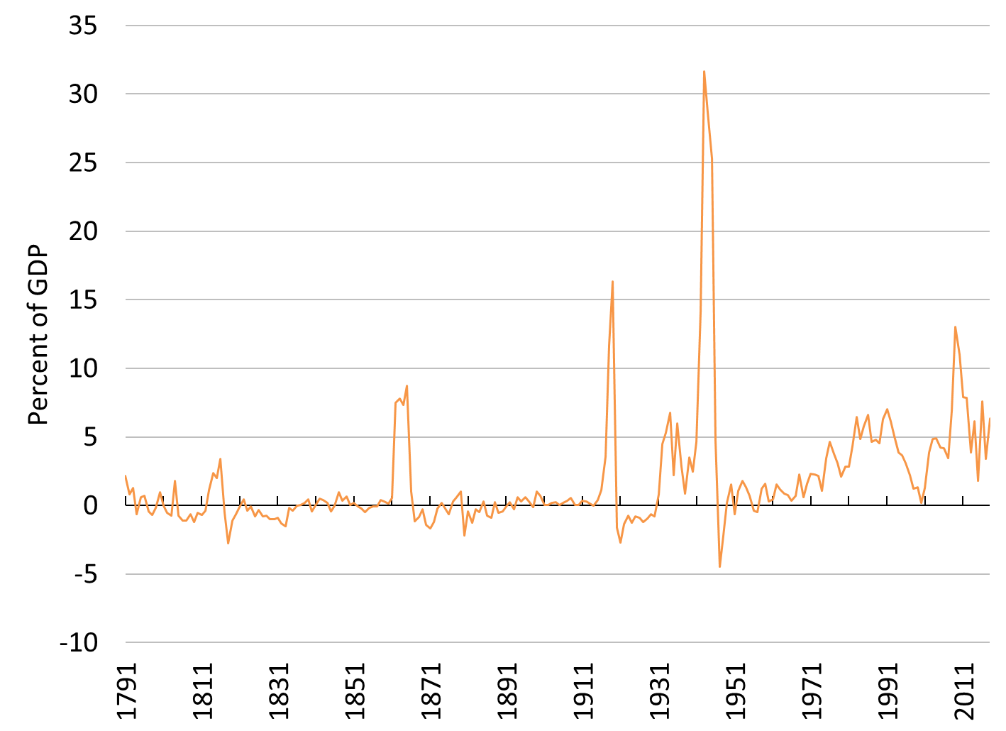

 | Change is |  | Average Size of Change in Gross Public Debt
Time Period | Positive | Negative | (% of GDP)
1791 to 1930 | 66 | 74 | 0.31
1931 to 2018 | 83 | 5 | 4.22
1791 to 2018 | 149 | 79 | 1.82
Figure 1. Change to Gross Public Debt relative to GDP: 1791-2018
Sources: Treasury Direct, Bureau of Economic Analysis.
Note: Division by GDP does not influence the type of changes (positive or negative) in the absolute gross public debt.
Fiscal Deficits are Normal, Get over It!
A confusion of private finances with public finances exists in the public debt rhetoric. Like any household or firm, the government should learn to put its finances in order. As President Obama put it:
The hard truth is that getting that deficit under control will require some broad sacrifices. That sacrifice must be shared by the employees of the federal government. After all, small businesses and families are tightening their belts. The government should too. And that’s why, on my first day as President, I froze all pay for my senior staff. This year I’ve proposed extending that freeze for senior political appointees throughout the government and eliminating bonuses for all political appointees. And today I’m proposing a two-year pay freeze for all civilian federal workers. This would save $2 billion over the rest of this fiscal year and $28 billion in cumulative savings over the next five years. (President Obama in Lee 2010)
The US government needs to learn to save like the rest of us. At the top of the policy agenda of most presidents is usually the goal of reaching a fiscal surplus over a given number of years; President Clinton was widely acclaimed for achieving the feat:
For 29 years, the last day of the fiscal year was not a day of celebration, but a day we were handed a powerful reminder of our government's inability to live within its means. In the 12 years before this administration took office, the debt quadrupled, partisan gridlock intensified, and a crushing debt was being imposed upon our children. These deficits hobbled economic growth, spiked interest rates, robbed too many people of their chance at the American dream. […] Tonight at midnight, America puts an end to three decades of deficits and launches a new era of balanced budgets and surpluses. It is a landmark achievement, not just for those in this room who have played a role in it, but indeed for all the American people. And it will be a gift-giving achievement for generations to come. (Clinton 1998)
This way of thinking is not only incorrect but also counterproductive. The main reason the US Treasury runs a deficit is not deliberate reckless policies or politicians who do not know how to put the US government finances in order. The US government actually has little control over the size of its expenditures and revenues.
Tax revenues are heavily influenced by the income earned by the domestic private sector and this fluctuates widely with the business cycle. In an economic expansion, tax revenues rise quickly because private-sector income rises, which may lead to a surplus if the expansion lasts long enough (like it did in the late 1990s). In a recession, tax revenues fall quickly because private-sector income falls, which rapidly reverses the fiscal position of the US government (like it did in 2000). Regarding government expenditures, a large portion of them is set by legal requirements (Social Security, Medicare, etc.) (Figure 2).
An implication of the countercyclical behavior of the fiscal position of the US government is that deficits become larger in periods of economic slowdown. While Reinhart and Rogoff (2009) argue that this shows that a high public debt slows economic growth, the causality is actually the reverse; slower economic growth causes higher deficits that rapidly raise the public debt (Taylor et al. 2012; Nersisyan and Wray 2011).

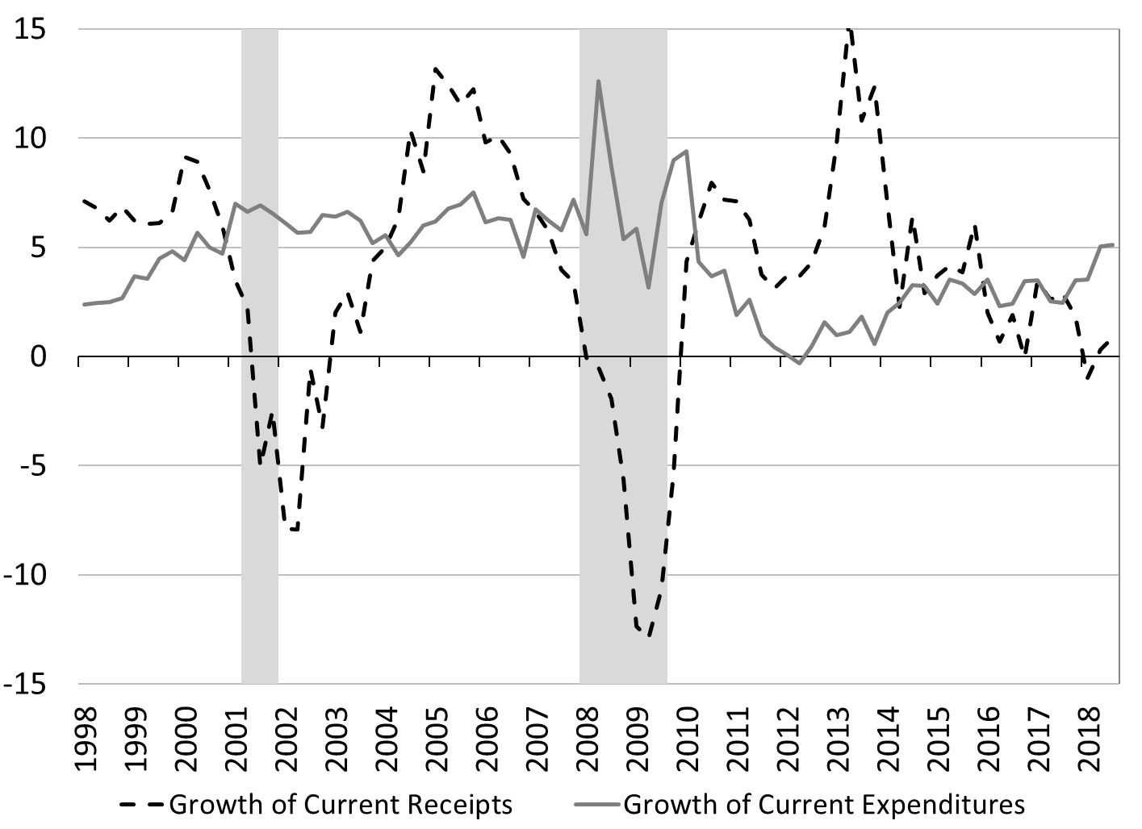
Figure 2. Growth rate of Receipts and growth rate of federal expenditures, percent
Source: Bureau of Economic Analysis.

This begs the question of what, if not the US government, determines the size of the fiscal balance and so the growth of the public debt. The main driver is the desire of non-federal sectors to accumulate financial net wealth. Deficits of the US government inject income in the domestic private sector, state and local governments and the foreign sector. Usually these sectors desire to save some of that extra income. They desire to do so because it provides them financial flexibility and because they have retirement needs, educational needs, among others.
President Obama’s quote reveals one of the ugly aspect of proactive fiscal deficit reduction, it comes at the cost of a decline in private-sector income. In the 1990s, while democrats celebrated the US government surplus, they also inadvertently pushed the domestic private sector into a deficit. In 1999, the Wall Street Journal provided a graph contrasting the US government surplus and personal saving (Figure 3). The newspaper reported that Clinton boasted that the “budget surpluses may wipe out the federal debt by 2015” while also noting that there was a “savings crisis” among US households; no connection was made between the two.

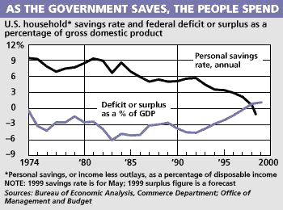
Figure 3. Fiscal balance and personal saving.
Source: Wall Street Journal, Tuesday, June 29, 1999, page A6.

At the macroeconomic level, the economy can be separated in three sectors, the government sector, the domestic private sector, and the foreign sector (or rest of the world). Accounting tells us that the financial balances (deficit, surplus, balanced) of these three sectors are interrelated by the following identity:
Government balance + Domestic private sector balance + Foreign balance ≡ 0
The central implication of that accounting identity is that at least the domestic private sector, the government sector, or the foreign sector must be in deficit if one of the sectors is in surplus. In the case of the United States, the domestic private sector and the foreign sector want to record a surplus. In order to achieve that surplus, the government sector must record a deficit. While the government may also want to reach a surplus, proactive policies to achieve such goal will impeded the ability of non-federal sectors to reach their desired surplus. A government-surplus agenda is implicitly a private-deficit agenda and/or foreign-deficit agenda.
Figure 4 illustrates the point by showing the financial balance of each major sectors of the economy. Usually the government sector runs a deficit and the other sectors record a surplus. In other words, fiscal deficits are a normal state of affairs for the US government. They have been so since the Great Depression, this is the norm throughout the world.

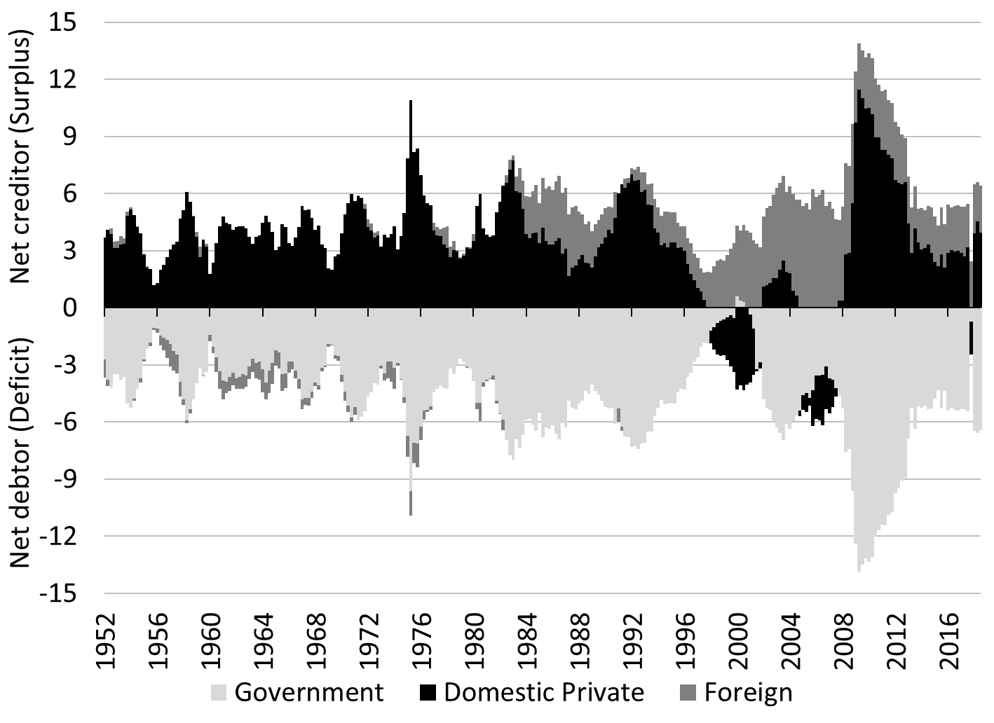
Figure 4. Financial balance (+ surplus, - deficit) of the foreign sector, domestic private sector and government sector, Percent of GDP.
Source: Board of Governors of the Federal Reserve System

The United States is special in the sense that the USD plays a central role in the international monetary system. This means that foreigners desire to accumulate USD and so the deficit must be larger than it would otherwise have been. If foreigners decide they do not want to hold US dollars assets, they can try to sell them quickly (which would negatively impact them) or they can start buying more goods and services from the US than they sell to the US. In the second case, the US government fiscal balance may move to a surplus in order to accommodate the will of the foreign sector to record a trade deficit with the US (Wray 2019). A few countries, mostly in Scandinavia recently, have been in such unusual situation.
Understanding the Implications of Monetary Sovereignty
Once one recognizes that deficits are a normal state of affairs, one may wonder if a growing public debt is financially sustainable. Given that the US government is monetarily sovereign, fiscal deficits are always financially sustainable. The implication of that sovereignty is not the US government can carelessly “print money” to pay the public debt and to spend at will; it is also not a call to allow direct financing of the Treasury by the central bank. The US Congress still must pass a budget in order to promote transparency and accountability, the US Treasury must still tax and issue securities, the Federal Reserve and the Treasury must still routinely coordinate their operations to ensure fiscal and monetary policies do not disturb the payment system (Tymoigne 2014, 2019). What monetary sovereignty implies is that the US government, not bond vigilantes, has control over the cost of its public debt, that it can decide what type of IOUs to offer to other sectors, and that the US government has the financial flexibility to spend on whatever its citizens decided is the public purpose as long as the things offered for purchased are priced in the domestic currency. Policymakers must still pay attention to potential resource constraints but they can safely ignore financial constraints.
As long as the nominal cost of public debt (i) stays low relative to the nominal growth of the economy (g), the public debt will not explode relative to the size of the economy. The normal case is for the interest rate on the public debt to be below the growth rate of the economy, i < g, precisely because a monetarily sovereign government has a strong control over the interest rate on its public debt. Olivier Blanchard recently received a lot of attention for emphasizing this empirical fact (when the literature usually assumes that i > g is the norm), but this was recognized long before him and linked to monetary sovereignty (Fullwiler 2006; Aspromourgos et al. 2009; Wray 2015).
Analysts who acknowledge that the US government is monetarily sovereign have long understood that there is zero probability of default on the US public debt; it is safe to assume that it will be serviced on time. The US government cannot be forced to default on its public debt as long as it is monetarily sovereign. When Standard & Poor’s downgraded US Treasuries in 2011, the hysteria about the debt reached a new peak, and yet again all informed pundits understood that a credit rating for the US public debt is irrelevant:
As the sole manufacturer of dollars, whose debt is denominated in dollars, the U.S. government can never become insolvent, i.e., unable to pay its bills. In this sense, the government is not dependent on credit markets to remain operational. Moreover, there will always be a market for U.S. government debt at home because the U.S. government has the only means of creating risk-free dollar-denominated assets (Fawley and Juvenal 2011)
This is not an issue of credit rating, the United States can pay any debt it has because we can always print the money to do that. So, there is zero probability of default (Greenspan 2011)
We’ve got the right to print our own money that’s the key. Greece lost their power to print their money. If they could print drachmas they would not have this problem. They’d have other problems, but they would not have a debt problem. Seventeen countries in Europe gave up their right to print their own money, that’s enormously important. We’ve got the right to print our own money so our credit is good (Buffet 2011)
Interest rates on US Treasuries proceeded to fall further after the downgrade as the Federal Reserve kept its course of pushing down rates. Once again, everybody was reminded that the financials are irrelevant for a monetarily sovereign government.
The fact that the US government can issue USDs does not means it ought to repay the public debt at once by “printing money”; this is a silly conclusion for several reasons. First, it is in nobody’s interest to repay the public debt and we will not. Second, the argument is usually that this will be inflationary because it will flood the economy with money, which makes one wonder why would we want to repay the public debt; once again it is in nobody’s interest to repay the debt. Third, the argument itself is spurious. The mechanics and impacts of making such one-time $22 trillion payments would not work the way described. The funds would not mostly go to households and businesses eager to spend on goods and services, but rather to financial companies, the Federal Reserve, the federal government, and official foreign institutions. Together they own about 70 percent of US Treasuries (Figure 5). In addition, once the funds are received, former public-debt holders would not spend but rather look for interest-earning opportunities, which given everything else would tend to push down interest rates. There is no direct or obvious impact on inflation, in the same way Quantitative Easing did not have an impact on inflation.
The US government does not, and ought not to, manage the public debt in the same way we manage our private debts. It is incorrect to analyze the finances of the US government by taking household and business finances as a point of reference. The public debt is managed to accommodate the needs of the economy rather than to prevent government bankruptcy. If other sectors want more public debt, the US government issues more. If other sectors want more long-term securities instead of short-term securities, the US government accommodates even if the interest rate on long-term securities is higher. If other sectors want to hold less public debt, the US government fiscal position turns into a surplus.

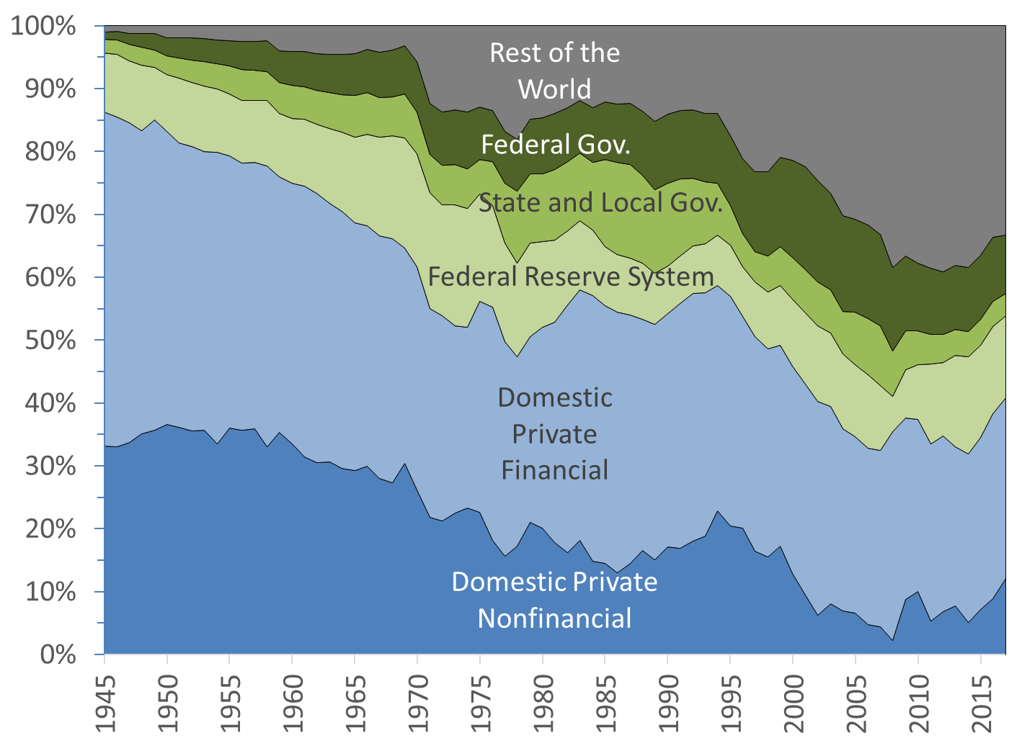
Figure 5. Structure of Ownership of US Treasuries, 1945-2017, percent
Source: Board of Governors of the Federal Reserve System

Deficits Do Not Hurt the Economy, They Help.
If a growing public debt is so concerning to some, it is because it is supposed to raise interest rates, slow economic growth, raise inflation, and raise tax rates. Even a casual look at the evidence shows that the concerns are not warranted and that prior beliefs should be reversed. Deficits help to stabilize the economy, deficits do not raise interest rates, deficits are not necessarily inflationary, and a rising public debt does not lead to higher tax rates. The public debt and fiscal deficits provide several benefits to the rest of the economy.
First, in the short-run, fiscal deficits are a boost to the saving level of the domestic private sector, state and local governments, and the rest of the world. Deficits sustain private incomes by injecting more money in the economy than they remove through taxes. Deficits sustain private investment by stabilizing the profit of businesses. Expected sales, not interest rates, are the main driver of business investment. Fiscal deficits boost the sales of businesses while having a negligible impact on the cost of credit.
The stabilizing effect of deficits can be seen in the data. The greater involvement of the US government in the economy has considerably reduced the volatility of economic growth without decreasing its level (Taylor et al. 2012; Hein 2018). Since the end of 1930s, the economy has recorded fewer contractions; contractions have been much milder, much less lengthy, and more spaced. Figure 6 shows that the growth rate of gross national product (GNP) is the same prior to, and after, World War II.

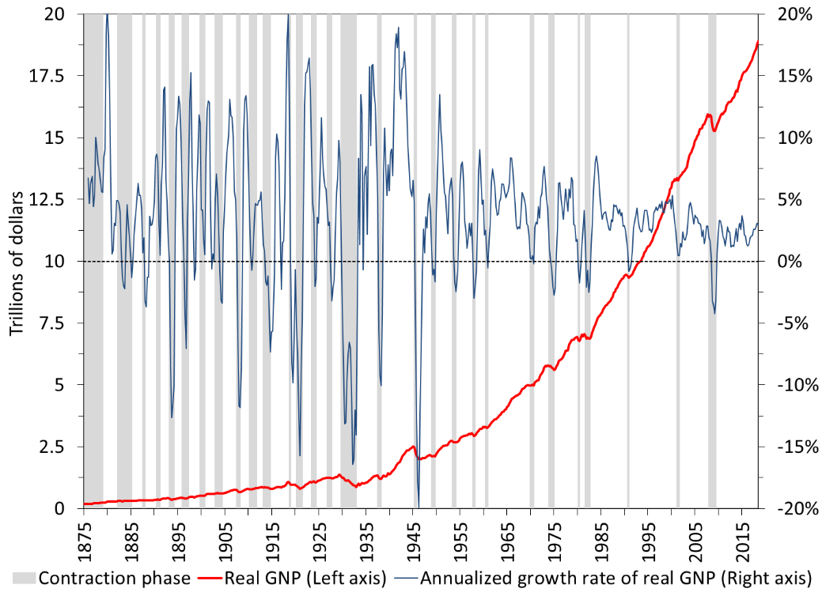
 | Number of contractions | Average Frequency (Year) | Average Length (month) | Average Declines in Real GNP | Average Growth Rate of Real GNP | Average St. Dev. of Real GNP
1880-1939 | 16 | 3.8 | 21.8 | -5.82% | 3.15% | 7.47%
1947-2018 | 11 | 5.8 | 11.1 | -1.65% | 3.18% | 2.63%
Figure 6. The U.S. Business Cycle: 1875:1-2018:3 (Base: 2012)
Sources: NBER, BEA, The American Business Cycle by R.J. Gordon (ed.).

Second, in the long run, deficits translate into the public debt. US Treasuries are credit-risk free (the nominal debt payment is always paid on time in full), highly-liquid financial instruments that are a core staple of the financial system. US Treasury securities provide non-federal sectors with a way to allocate their financial net wealth in a safe way. Treasury securities are also safe collateral and are a core means to meet the requirements of financial regulations.
Third, there is no relationship between the fiscal balance of the US government and interest rates. Fiscal deficits do not raise interest rates; fiscal surpluses do not lower them. Interest rates are not driven by the fiscal policy of the US Treasury; they are driven by the monetary policy of the Federal Reserve (Figures 7 and 8). The financial crowding out does not exist in a monetarily sovereign country (Sharpe 2013; Borio et al. 2017). When the US Treasury runs very large deficits, it usually does so in periods of recession when tax revenues plummet. During these periods, the Federal Reserve also lowers its policy rates to help the economy and all other interest rates follow. During World War II, when the fiscal deficit ran past 20% of GDP as government spending increased very rapidly, the Federal Reserve set all interest rates on the US public debt very low for years and private interest rates followed and stayed low for years.

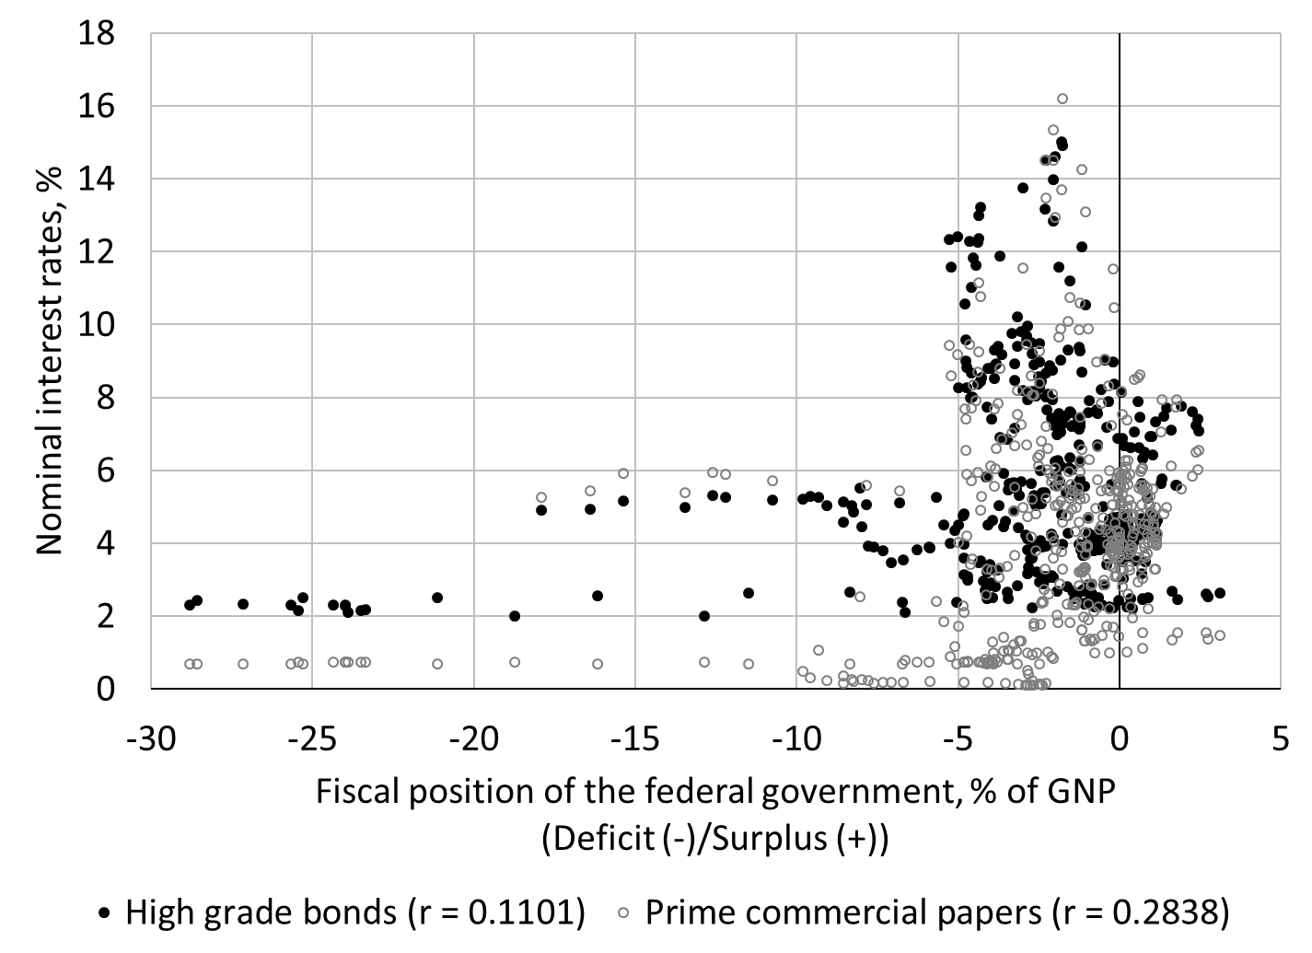
Figure 7. Fiscal position and interest rates, Q1 1900 to Q4 2016.
Sources: Treasury Bulletin, National Bureau of Economic Research, Monthly Receipts, Outlays, and Deficit or Surplus, Fiscal Years 1981-2017.

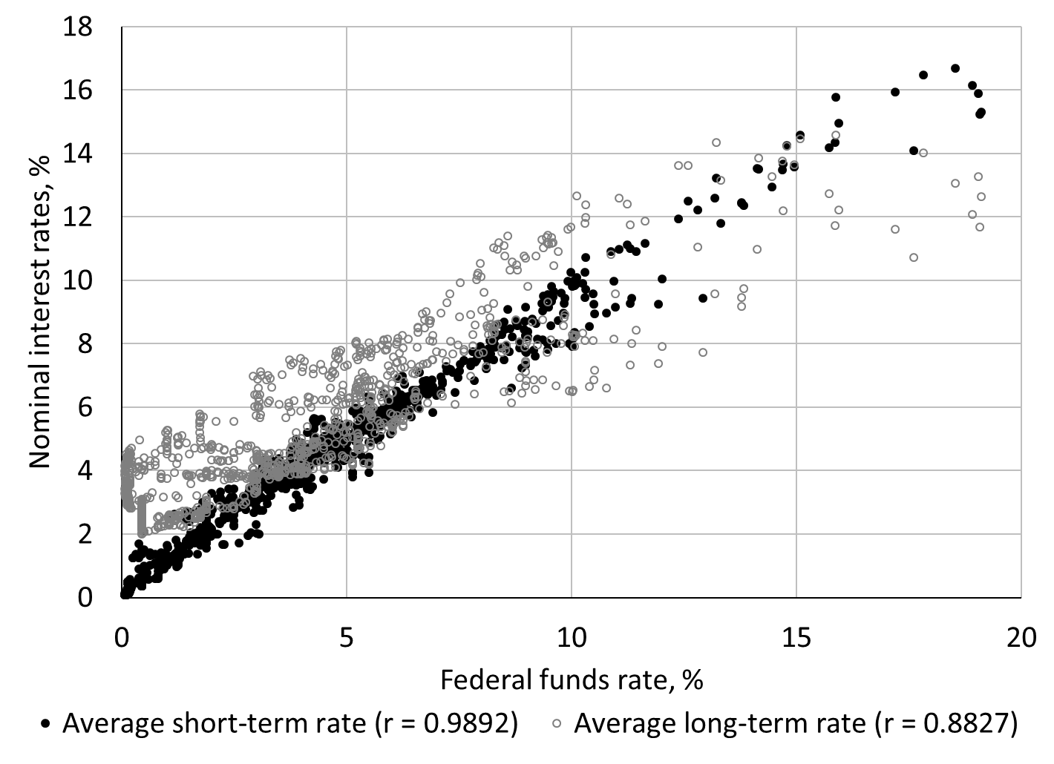
Figure 8. Monetary policy and nominal interest rates, January 1919 to December 2015
Sources: National Bureau of Economic Research.

Fourth, in terms of tax rates, one must come to recognize that the public debt will never be repaid. There is no reason to do so, and doing so would be harmful to the finances of non-federal sectors for the reasons provided above. We have not been burdened with higher tax rates to repay the public debt created at the time of our grandparents; our children and grandchildren will not be burdened by higher tax rates to repay the public debt created today. We may raise tax rates in the future but not with the goal of repaying the public debt. The public debt will keep piling up to accommodate the needs of our growing economy and the US government will keep paying it on time as long as it is monetarily sovereign.
Finally, in terms of inflation, a casual look at the evidence shows that there is no obvious relationship between the fiscal balance and inflation (Figure 9). The automatic association of deficit with inflation is unwarranted (correlation is -0.16). During World War II, the US government managed to control inflation through price controls, rationing and higher tax rates. Other periods in time have any range of inflation for a given fiscal balance. A fiscal deficit might be inflationary but not merely because it is a deficit; it depends on how tight the resource constraint is and it depends on the effectiveness of the measures taken to control inflation are when full employment is prevalent. Similarly, a fiscal surplus might be deflationary but not merely because it is a surplus.

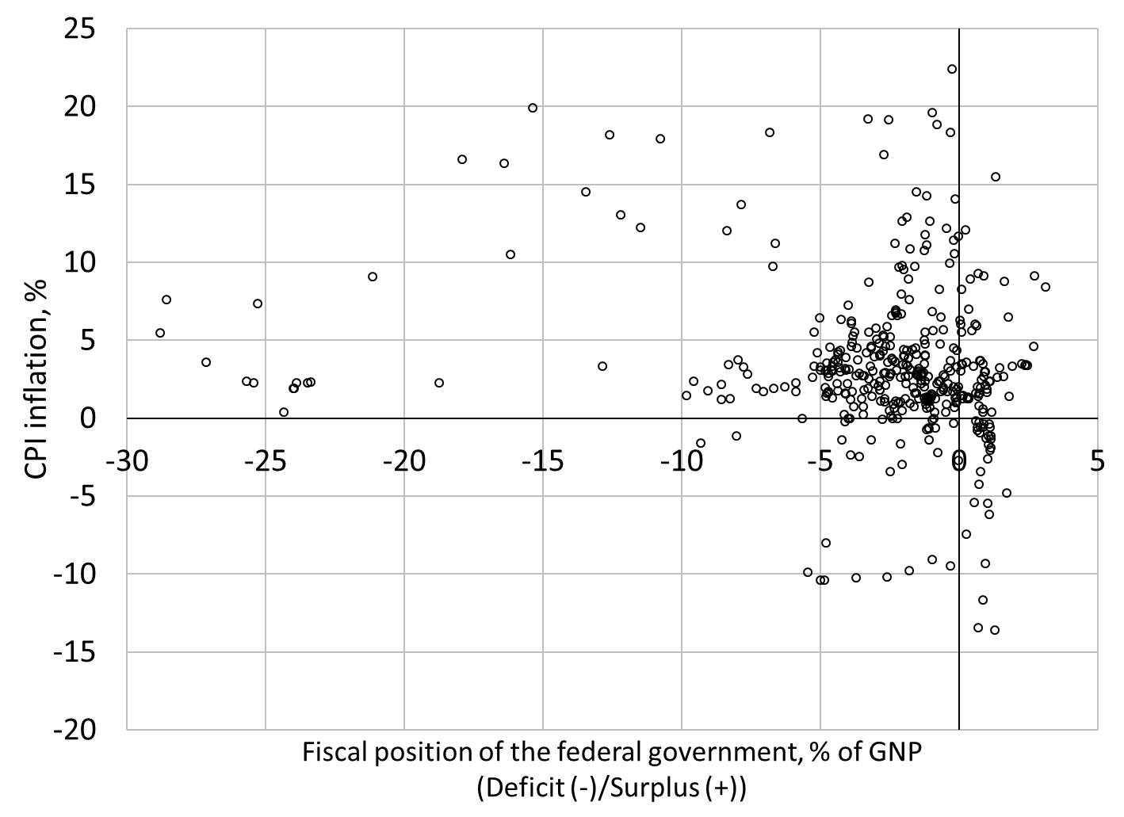
Figure 9. Fiscal policy and inflation
Sources: See Figure 7 and Bureau of Labor Statistics.
Note: Quarterly data from Q1 1913 to Q42015

Stop staring at numbers on a spreadsheet and start focusing on the real issues
Government policies should not set a direct or indirect goal of achieving any specific fiscal position. The government should let its fiscal balance move automatically to whatever it needs to be in order to accommodate the desires of the other sectors to improve their financial standing. The non-federal sectors usually desire to be in surplus even during an expansion, so the government should be in deficit even during an expansion. We should forget altogether about the fiscal balance and the public debt and pay attention to the real issues of our times. Fiscal policy should be judged on that ground not on the ground of financial solvency.
There are two intertwined aspects to the outcomes of fiscal policy, short-run outcomes and long-run outcomes. Short run outcomes involve promoting price stability, financial stability and full employment. A temptation may be to measure the desired non-federal surplus to determine a target fiscal balance; this is not an appropriate way to proceed. The desired non-federal surplus moves over the business cycle and it impossible to measure properly. The only clue policymakers have is the state of the economic at a point in time. If the deficit is too large relative to the desired surplus of the non-federal sectors, inflation may emerge; if the deficit is too small relative to the desired surplus of the non-federal sectors, a recession may occur. In both cases, the fiscal balance will tend to self-correct through the automatic stabilizers but the US government usually wishes to be more proactive through ad hoc one-time interventions. While this usually helps, a more effective way to proceed is to put in place structural programs that reinforce the automatic stabilizers by directly tackling unemployment and inflation (Wray et al. 2018; Tymoigne 2010).
The long-run real outcomes involve dealing with the critical problems of our times. This requires a deep discussion among US citizens about the role that the government needs to play in dealing with them. What are indicators of health for our economy? Standard of living, life expectancy, literacy rate, availability and quality of childcare and healthcare are major indicators. Moderate income and wealth inequalities that encourage individual initiatives but also keep individuals engaged with their society, quality infrastructures that accommodate the needs of the society, and environmental sustainability are others. We are failing on a number of these indicators of economic health. For example, our civil infrastructure requires trillions of dollars to be brought back up to standard (American Society of Civil Engineers 2017). Today, the greatest threat is environmental sustainability, not only in terms of climate change, but also in terms of the sustainability of our consumption-oriented society. A Green New Deal would be a good start but much more would be needed in the US and abroad.
Responding effectively to these pressing issues will require massive government spending, and will generate a rapid increase in the public debt, here and abroad. We did it during World War II, we can do it again. The main barriers to government intervention are the will of its citizens and the ability of their voice to be heard in the political process (pools show that a majority of the US population wants something to be done about climate change, poor access to healthcare, and unaffordable college education). As long as citizens are not willing or able to involve the government, dealing with structural issues is delayed and the size and speed of necessary adjustments increase. As such, the inflationary aspect of such large-scale programs will depend on how fast the spending needs to be done relative to the growth of available resources.
However, one must recognized that the US government usually has more fiscal space than it is acknowledged. Most analysists like to start their analysis from a fully-employed economy and wonder immediately what needs to be given up in order to implement specific programs. This is counterproductive and it stifles innovative thinking by focusing on what is not possible instead of what is possible. Usually the economy is below full employment so there is no opportunity cost. In addition, more flexibility can be added by planning the implementation of programs over a number of years and by implementing programs that deal with local bottlenecks (Keynes 1937; Tcherneva 2012). At full employment, higher tax rates and other policies may be needed to tame inflation. Some have argued that raising tax rates may not be politically possible but, presumably, citizens who already agreed that more government involvement is needed will be accommodative of such an increase. Once again, the politics become all important, not the financials.
The question US citizens have to ask themselves is if tackling these issues is more important than a number on a spreadsheet. While solving these issues might require sacrifices in terms of productive resources, especially if a rapid reengineering of our economy is require, it will not require any sacrifice in financial terms for the US government and our grandchildren. What is productively possible is always financially possible for a monetarily sovereign government. We may have to declare War on Climate Change for policymakers to realize that.
Bibliography
American Society of Civil Engineers (2017) Infrastructure Report Card. Available at https://www.infrastructurereportcard.org/
Aspromourgos, T., Rees, G. and White, G. (2009) “Public debt sustainability and alternative theories of interest.” Cambridge Journal of Economics, 34 (3): 433-447.
Borio, C, Disyatat, P., Juselius, M.I., and Rungcharoenkitkul , P. (2017) “Why so low for so long? A long-term view of real interest rates” BIS Working Paper, No. 685. Available at https://www.bis.org/publ/work685.pdf
Buffet, W.E. (2011) Comments in Bloomberg’s In the Loop, July 8.
Cantor, R. and Parker, F. (1995) “Sovereign Credit Ratings,” Federal Reserve Bank of New York Current Issues in Economics and Finance, 1 (3): 1-6.
Clinton, W.J. (1998) “President Clinton Announces the First Budget Surplus in a Generation” White House, Press Release, September 30. https://clintonwhitehouse4.archives.gov/WH/New/html/19980930-11446.html

Fawley, B.W. and Juvenal, L. (2011) “Why Health Care Matters and the Current Debt Does Not.” St. Louis Fed’s The Regional Economist, 19 (4), October: 4-5. Available at https://www.stlouisfed.org/publications/regional-economist/october-2011/why-health-care-matters-and-the-current-debt-does-not
Furman, J. (2019) “What You Need To Know About The $22 Trillion National Debt” Interview on National Public Radio’s All Things Considered, February 14. Available at https://www.npr.org/2019/02/14/694914495/what-you-need-to-know-about-the-22-trillion-national-debt
Fullwiler, S.T. (2006) “Interest Rates and Fiscal Sustainability” Center for Full Employment and Price Stability, working paper #53. Available at http://www.cfeps.org/pubs/wp-pdf/WP53-Fullwiler.pdf
Government Accounting Office (2001) FINANCIAL AUDIT: Bureau of the Public Debt’s Fiscal Years 2000 and 1999 Schedules of Federal Debt. Available at https://www.treasurydirect.gov/govt/reports/pd/feddebt/feddebt_ann2000.pdf

Greenspan, A. (2011) Comments on Meet the Press “US Debt Downgrade” August 7.
Hein, E. (2018) “Autonomous Government Expenditure Growth, Deficits, Debt, and Distribution in a Neo-kaleckian Growth Model.” Journal of Post Keynesian Economics, 41 (2): 316-338.
Irwin, N. (2019) “How America Learned to Stop Worrying and Love Deficits and Debt” New York Times, Feb. 23. Available at https://www.nytimes.com/2019/02/23/upshot/how-america-learned-to-stop-worrying-and-love-deficits-and-debt.html
Keynes, J.M. (1937) “How to Avoid a Slump.” Times, January 12-14. Reprinted in The Collected Writings of John Maynard Keynes (ed. Moggridge, D.), vol. 21, 384-395. Cambridge: Cambridge University Press.
Lee, J. (2010) “President Obama on the Federal Pay Freeze: "Getting This Deficit Under Control is Going to Require Broad Sacrifice". White House Blog, November 10 at 4:32PM. Available at https://obamawhitehouse.archives.gov/blog/2010/11/29/president-obama-federal-pay-freeze-getting-deficit-under-control-going-require-broad
Nersisyan, Y. and Wray, L.R. (2011) “Does excessive sovereign debt really hurt growth?” Revue de l’OFCE, 11 (1): 173-190. Also available at http://www.levyinstitute.org/publications/does-excessive-sovereign-debt-really-hurt-growth
Rattner, S. (2019) “Your Grandchildren Are Already in Debt” New York Times, February 11. Available at https://www.nytimes.com/2019/02/11/opinion/debt-tax-democrats-presidential-elections.html
Reinhart, C. and Rogoff, K. (2009) This Time is Different: Eight Centuries of Financial Folly, Princeton: Princeton University Press.
Sharpe, T.P. (2013) “A Modern Money Perspective on Financial Crowding-out.” Review of Political Economy, 25 (4): 586-606.
Taylor, L., Proaño Laura de Carvalho, C.R. and Barbosa, N. (2012) “Fiscal deficits, economic growth and government debt in the USA” Cambridge Journal of Economics, 36 (1): 189–204.
Tcherneva, P. (2012) “On-the-spot Employment: Keynes’s Approach to Full Employment and Economic Transformation.” Review of Social Economy, 70 (1): 57-80.
Tymoigne, E. (2010) “Minsky and Economic Policy: ‘Keynesianism’ all over again?” In Papadimitriou, D. and L.R. Wray (eds.), The Elgar Companion to Hyman P. Minsky, 47-83. Northampton: Edward Elgar.
Tymoigne, E. (2014) “Modern Money Theory and the Interrelation between the Treasury and the Central Bank: The Case of the United States.” Journal of Economic Issues, 48 (3): 641-662.
Tymoigne, E. (2019) “Can the US Treasury run out of money when the US government can’t?” New Economic Perspective, blogpost. Available at http://neweconomicperspectives.org/2019/03/can-the-us-treasury-run-out-of-money-when-the-us-government-cant.html
Wray, L.R. (2015) Modern Money Theory: A Primer on Macroeconomics for Sovereign Monetary Systems, 2nd edition. New York: Palgrave
Wray, L.R. (2019) “Does America Need Global Savings to Finance Its Fiscal and Trade Deficits?” Foreign Affairs, 3 (1), Spring. Available at https://americanaffairsjournal.org/2019/02/does-america-need-global-savings-to-finance-its-fiscal-and-trade-deficits/
Wray, L.R, Dantas, F., Fullwiler, S., Tcherneva, P.R. and Kelton, S.A. (2018) Public Service Employment: A Path to Full Employment, Levy Economics Institute, Research Project Report, April. Available at http://www.levyinstitute.org/pubs/rpr_4_18.pdf

Fiscal surpluses did lead to a fall in the public debt held by the public (the Treasury bought back some of its IOUs from non-federal sectors) but intragovernmental holdings grew and more than offset the decline (Government Accounting office 2001).
The actual identity is (S – I) + (T – G) + Foreign NX ≡ 0 from the National Income and Product Accounts. The Financial Accounts provide a similar identity but from the perspective of balance sheets instead of national income: Net Lending of the Domestic Private Sector + Net Lending of the Government Sector + Net Lending of the Foreign Sector ≡ 0.
Cantor and Parker provide rare examples of governments that defaulted on debts denominated in their own unit of account and note that “Domestic currency defaults have usually been the result of an overthrow of an old political order—as in Russia and Vietnam—or the byproduct of dramatic economic adjustment programs aimed at curbing hyperinflation—as in Argentina and Brazil” (Cantor and Parker 1995, 3).
In 2014, the Financial Accounts stopped providing data that splits the structure of ownership of public debt within the foreign sector in 2014. Prior to that, data shows that two thirds of the US public debt held by the rest of the world is held by official foreign institutions (foreign central banks, foreign Treasuries, among many others)

