Package Shipment Information

Follow these instructions so that the items you ship here will be available when you arrive on campus. Please take precautions to properly protect and secure the items in your boxes, so that they will not arrive here broken or damaged. All shipments must be prepaid. Sorry, but we cannot accept COD shipments.

IF YOU LIVE IN THE CONTINENTAL UNITED STATES

Ship via UPS or the US Postal Service on or after August 12th. Plan to have your belongings arrive in Portland by August 23rd. If you meet that deadline, they should be waiting for you in your residence hall room on August 28th when you arrive on campus for New Student Orientation. Remember, if you are a student athlete and are required by your coach to arrive earlier than August 28th, bring all the items you will need for pre-season practice with you, including towels and bedding. **Please keep individual package weight under 50lbs and in boxes that are a manageable size.

1st Choice Shipping Method: Ship via UPS. If you send five boxes, for example, mark each box “1 of 5,” “2 of 5,” “3 of 5” and so on. Please write the name of your residence hall and “NSO” on every box you ship. Bring the receipt (or a copy of it) for your shipment with you to campus. Address your boxes as follows:
Lewis & Clark College
Your Name, MSC ____
0615 SW Palatine Hill Road Portland OR 97219-7899

2nd Choice Shipping Method: Ship smaller boxes via the U.S. Postal Service. If you send five boxes, for example, mark each box “1 of 5,” “2 of 5,” “3 of 5” and so on. Please write the name of your residence hall and “NSO” on every box you ship. Bring the receipt (or a copy of it) for your shipment with you to campus. Address your boxes as shown above.

If your belongings arrive after August 23rd they may not be delivered to your residence hall. The mailroom will be open the first day of orientation for you to pick up your items.

IF YOU LIVE OVERSEAS, IN ALASKA OR HAWAII

Ship your trunks or boxes by air on or after August 10th. Plan to have your belongings arrive in Portland by August 23rd. If you meet that deadline, they should be waiting for you in your residence hall room on August 28th when you arrive on campus for New Student Orientation. (Please note that some shipping companies will not deliver to campus, unless you pay an extra fee. If the company won’t deliver to campus, you will be responsible for picking up your own packages.) If you send five boxes, for example, mark each box “1 of 5,” “2 of 5,” “3 of 5” and so on. Please write the name of your residence hall and “NSO” on every box you ship. If you are an international student arriving on August 26 th for International Student Orientation, please be advised that in addition to the notations mentioned above, please indicate your arrival date as well. Bring the receipt (or a copy of it) for your shipment with you to campus.
Address your trunks and boxes as follows:

Lewis & Clark College
Your Name, MSC ____
0615 SW Palatine Hill Road Portland OR 97219-7899

Destination verification: 503-768-7867

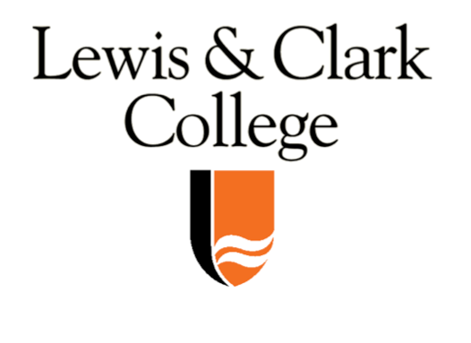
2019 – 2020 Academic Calendar

To assist you in planning transportation to and from the campus for the year, we provide the following information. Please note the residence halls remain open (at no additional cost) during Fall, Thanksgiving, and Spring Breaks, however, food service and shuttle services are not provided. After final exams, students may not remain in campus housing beyond the published closing times.

FALL SEMESTER 2019
Residence Halls open at 8am Wednesday, August 29, 2019

August 28 – September 1 .............................................................................................................New Student Orientation
August 28 - 29 .................................................................................................................................................Parents Preview
September 3 ...............................................................................................................................................First Day of Classes
September 13................................................................................................................Last Day to Register or Add/Drop
October 10 – 13 ....................................................................................................................................Fall Break [no classes]
October 14 – November 1................................................................................................Registration advising for 20/SP
October 25 – 27 ...............................................................................................................Family Weekend/Homecoming
November 4 – 14 ..................................................................................................................Registration for 20/SP courses
November 28 – December 1 ..................................................................................................................Thanksgiving Break
December 11 ...........................................................................................................................................Last Day of Classes
December 12 -13..............................................................................................................................................Reading Days
December 14, 16, 17, 18 ......................................................................................................................................Final Exams
Residence Halls close at 3pm on Thursday, December 19, 2019

SPRING SEMESTER 2020
Residence Halls open at 9am on Sunday, January 19, 2020

January 21 ...............................................................................................................................................First Day of Classes
January 31 ......................................................................................................................Last Day to Register or Add/Drop
March 9 - April 3 ................................................................................................................Registration advising for 20/FA
March 21 - March 29......................................................................................................................................Spring Break
April 7 - 16..............................................................................................................................Registration for 20/FA courses
April 30 .......................................................................................................................................................Last Day of Classes
May 1 – 2.................................................................................................................................................................Reading Days
May 4 - 7....................................................................................................................................................................Final Exams
Residence Halls close at 3pm on Friday, May 8, 2020

