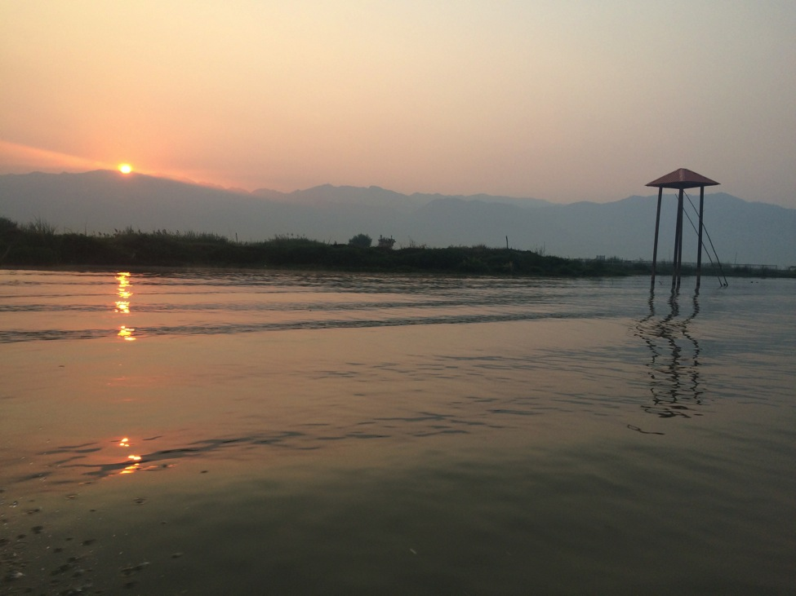
International Development Studies
Introductory Research Guide for Lewis & Clark Students 2015-2016

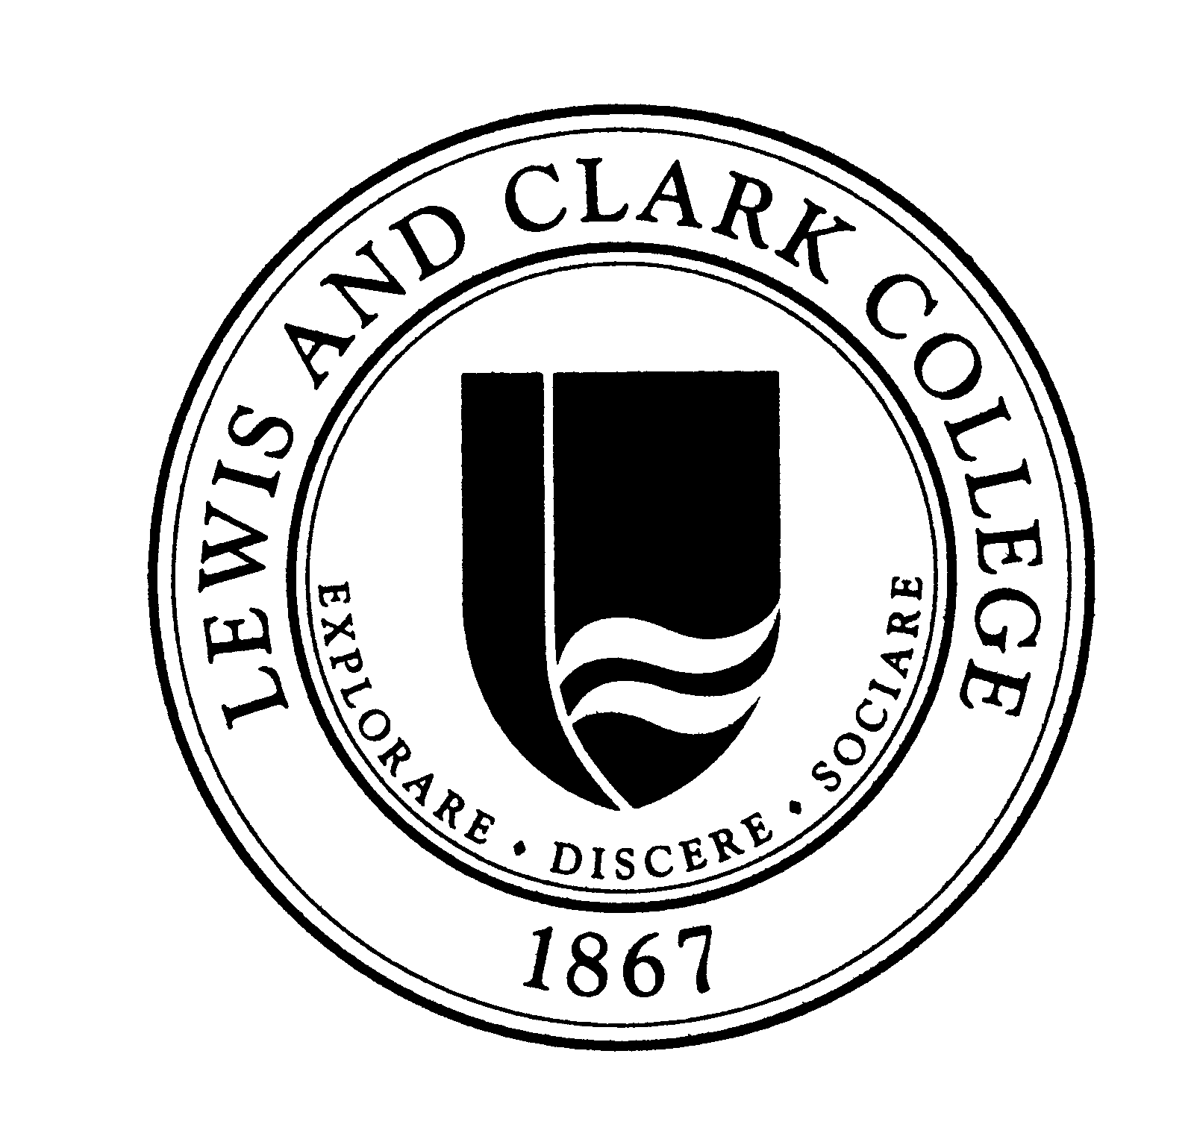
A Collaboration w/: Watzek Library – Overseas and Off-Campus Programs – College of Arts & Sciences – Renewable Energy Fee Fund
Compiled by Keith Morency ‘16

Table of Contents
Introduction 3
Defining Development 4
Possible Areas of Study in Development 5
Key Introductory Works 6
Types of Organizations Involved in Development Work 7
Development Research Ethics 8
Interview Etiquette 9
Research Funding Opportunities at Lewis & Clark 10
Sharing Research Outcomes 11
Development Studies: Available Resources in Portland and Beyond 12
Conclusion 14

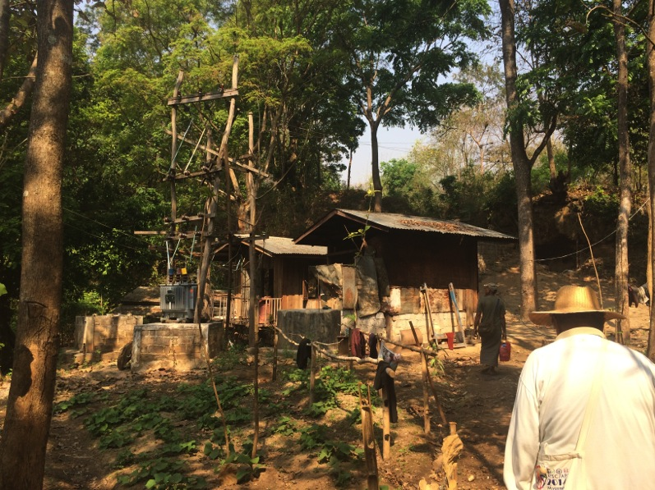

Introduction

This guide is meant to be a starting point for Lewis & Clark CAS students who may be interested in international development research, but may not have any background in the field. During my time at Lewis & Clark I was fortunate enough to travel to several different countries, where I conducted interviews, visited multiple different development project field sites, and participated in a “sustainable” school building project. I am incredibly thankful for these experiences and encourage all students to consider study abroad programs. If we are to solve global issues, we must first learn how to place ourselves in the world.
Acknowledging that I am far from an expert in this field, I still would like to share my experiences in both planning and executing this research, as well as provide some tips for how to approach the research process and share outcomes with the community. My goal is to help students consider the field of development from multiple perspectives before traveling, understand their options in terms of funding and outcome sharing, and ultimately produce quality work that can contribute to both the Lewis & Clark and international communities. In the absence of a formal Development Studies program, I’m hoping that this document will help guide students to think about these issues.
Development work can come in many forms, as we will see in a moment, and is a critically important field and area of study. Lewis & Clark students have incredible resources at their disposal. Hopefully this research guide will inspire students to utilize those resources and to participate in international development efforts in a conscientious and professional manner.

Sincerely,
Keith Morency ‘16

***All photos taken by the author on Lewis & Clark-sponsored trips to Myanmar, Vietnam, Japan and Guatemala between 2014-2016***

Defining Development

“Development” is a truly massive term when one considers the range of possible subcategories that could be applied to it. Development strategies and approaches can be applied to everything from a single project to an international campaign. Therefore, it is important to identify which specific area of development you are concerning yourself with. The distinction between economic growth and economic development is a good place to start, as these terms can often be used interchangeably but are different in very fundamental ways.

Economic Growth = A rise in national or per capita income and product.

Economic Development = Improvements in health, education, and other aspects of human welfare (e.g. energy and transportation infrastructure, agricultural systems, etc.).
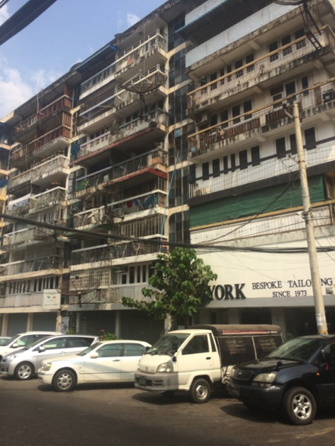
These two concepts, while different in principle, are undeniably related. Growth without development is a very rare phenomenon, and therefore must be considered in tandem. Conflating them, however, can seriously complicate your studies in this field.
At the same time, economic development does not necessarily need to be approached from an economics perspective, as is more often the case with economic growth. Economic and social development (which from now on will be referred to just as “development”) can also be approached from a political perspective, a sociological or anthropological perspective, an international affairs perspective, and in many cases the more perspectives that can be lent to development concerns, the better. Development is mainly any action that directly affects humans, and therefore can be a very complex, multi-faceted process. I encourage students of all backgrounds to consider their role in global development.

Possible Areas of Study in Development

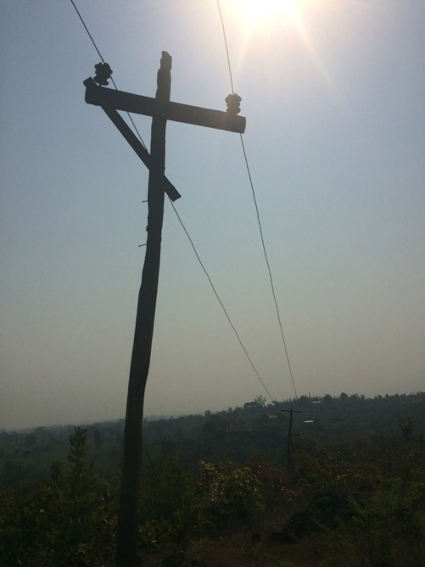

- Agriculture
- Education
- Energy
- Healthcare
- Housing
- Industry
- Population, Health, and Nutrition
- Transport
- Urbanization
- Water and Sanitation
This list is not exhaustive by any means, but is simply an introduction to the many different areas of study that could be pursued from a development standpoint. There are also many subcategories within each of these categories that could be explored in depth. In fact, I encourage this approach, and it will allow for more specific recommendations and avoids the risk of oversimplification or overextension of research. For a more comprehensive list, visit: https://en.wikipedia.org/wiki/Development_studies

Key Introductory Works

This list is meant to serve as a starting point for thinking about development as a concept, as well as offer some of the contentious opinions on the field from multiple respected scholars. It is drawn from the Suggested Reading List for Development Studies module at the King’s College of London.

- Cowen, M., and Shenton, R. (1998) Doctrines of Development. London: Routledge.
- Escobar, A. (1995) Encountering Development: The Making and Unmaking of the Third World. Princeton: Princeton University Press.
- Martinussen, J. (1997) Society, State and Market: A Guide to Competing Theories of Development. London: Zed Books.
- Sen, A. (1999) Development as Freedom. Oxford: Oxford University Press
- Sumner, A. and Tribe, M. (2008) International Development Studies. London:Sage.
- Toye, J. (1987) Dilemmas of Development: Reflections on the Counter-Revolution in Development Economics. Oxford: Blackwell.
- UNDP (United Nations Development Programme- Annually Human Development Report. New York: Oxford University Press for the UNDP.
- Willis, K. (2011) Theories and Practices of Development, London: Routledge
- World Bank (Annually) World Development Report. New York: Oxford University Press for the World Bank
- ELDIS Gateway: http://www.eldis.org/

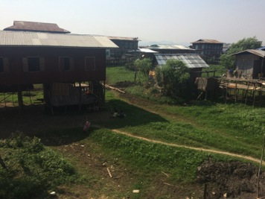

Types of Organizations Involved in Development Work

MULTILATERAL ORGANIZATIONS (Examples: United Nations Development Program (UNDP), World Bank)

- Super-national bodies that have been created with representatives from the governments of many member states. These may be closed groups, e.g. NATO or theoretically open organizations, e.g. the United Nations.

BILATERAL ORGANIZATIONS (Examples: United States Agency for International Development (USAID), Department for International Development (DFID))

- These are government bodies that focus on development in foreign countries, often with an underlying goal of furthering their domestic policies or gaining political credit. In some cases the aid is not tied to any conditions, but normally funding is used for some degree of political influence.

RESEARCH INSTITUTIONS (Examples: universities, think tanks)

- Defined as any group involved in investigative study for scientific or educational purposes. They may be privately owned or funded by the state.

PRIVATE SECTOR (Examples: commercial companies)

- This is a term that describes any privately owned group or person involved in profitable activities. Of course this is a huge group, and distinct from the other categories as organizations within the private sector are all for-profit.

CIVIL SOCIETY ORGANIZATIONS (Examples: Oxfam, Bill and Melinda Gates Foundation)

- Also known as Non-Governmental Organizations (NGOs), Non-Profits & Not-for-Profits. Civil society is an umbrella term for an extremely diverse and numerous group, including charities, religious and private foundations. There are both international and national civil society groups. Civil society groups are started and owned by private individuals or organizations. They are independent of governments, but may receive (in some cases substantial) funding from governments.

Source: http://www.developmentworker.com/the-different-types-of-development-organizations/

Development Research Ethics

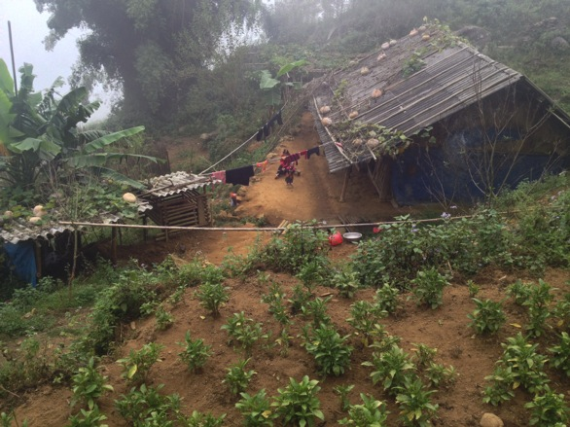
While it may not seem obvious at first, development studies inherently contain some bristly ethical issues, which must be carefully understood and considered before conducting research. If your research is purely economic, then you may be less likely to encounter these issues, although the possibility still remains. Tvedt (1998) claims that “reflections on research ethics in [development studies] must take note of conflicting, although not necessarily irreconcilable, value systems among different societies (212).” Essentially, as researchers we must understand that our training and our background places us within several different value hierarchies and systems, which may not align with those of the societies we are analyzing. This requires careful consideration of biases that may be embedded in certain source material, political or economic motivations behind certain data sets, etc. In order to help you, the researcher, navigate the complex world of development studies ethics, I have listed links to several documents that outline these issues in far greater detail than space permits here:

- Andrew Summers, “What are the Ethics of Development Studies?” IDS Bulletin March 2007
- “Research Ethics,” page from website of Institute of Development Studies (includes link to full Research Ethics Policy pdf)
- Australian Development Studies Network, “Ethics and Development”, Development Bulletin April 1994

Interview Etiquette

Now that you have considered your ethical approach to development research in general, you now must begin to understand the specific cultural etiquette that will be expected of you in the country you are visiting. Drawing from the piece “Interviewing Across Cultures,” by Pamela Leri, I have listed below some of the main questions you should be asking yourself before going into an interview, especially in a foreign country or environment. I’ve conducted several different interviews in multiple countries, and this required doing my homework on what would be expected of me going into the meeting. Some questions to consider:

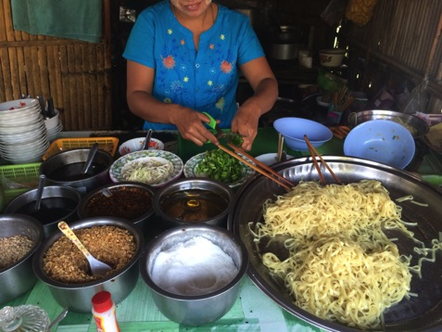
- What will impress the interviewer?
- What are the local expectations for establishing credibility?
- Are these expectations different for local people than they are for foreign nationals?
- How do these expectations differ from what you are accustomed to?
- How can you adjust your behavior to be credible and effective in the interview?

The rest of Leri’s piece goes on to describe other points to consider when attempting to understand interview expectations, such as dress and appearance, formality, pacing of the conversation, etc. It also lists notes on interview etiquette by global region, with specific case studies for certain countries. It is a very helpful piece and I highly recommend reading it before attempting any interviews and (potentially) committing some cultural snafus. I have provided a link here:

- Pamela Leri, "Interviewing Across Cultures," Guest Columnist, www.goingglobal.com

Research Funding Opportunities at Lewis & Clark

Lewis & Clark College has a number of funds that have been made available for student research and project initiatives. Here is a list of some of the funds that may be particularly helpful when attempting development research. Keep in mind that it is always best to apply early to allow for ample time to plan. Also, you may want to partner with an organization in the country that you would like to visit. This can make logistics such as transportation and lodging far easier to organize, especially if there is a significant language barrier.
Internally Available Funds

SAAB (Student Academic Affairs Board)
From ASLC’s website: “The SAAB grant program funds student research initiatives and other academic expenses via a board of student representatives from each academic discipline . . . The Board meets weekly to hear academic grants which extend student’s academic experiences beyond the sphere of campus, and which return value to the student body.” You can find an application here: SAAB Application Research Grant

REFF (Renewable Energy Fee Fund)*
From lclark.edu: “As the costs associated with purchasing renewable energy certificates (REC) have come down over the years, surplus funds from the Renewable Energy Fee have become available to students.” Research must have a particular focus on renewable energy or “Green Power.” Application: REFF Grant Application

Externally Available Funds

Japan Foundation: Center For Global Partnership
More info can be found here.

United States Institute of Peace
More info can be found here.

Sharing Research Outcomes

Of course, a critically important part of conducting development research is then sharing what you learned, whether that be with the Lewis & Clark community, Portland development community, or the international community. Development issues can often be incredibly complex, which can make non-traditional outcomes (such as a poster or media presentation) difficult to create. The most important goal should be to communicate your findings clearly and efficiently, so as to both keep your audience interested and engaged. Here are some notes and links for different presentation styles via which you could choose to present your research findings:

- Oral Presentation:
  - Effective method of addressing a large group of people at once, speaking in depth about your research with visual cues. Oral presentations strike a happy medium between poster presentations and long paper outcomes.
  - You can find some helpful tips here.

- Poster Presentation:
  - Many Lewis & Clark majors will require you to make a project poster at some point in your academic career. They are a great way to synthesize information in a visual and compelling manner, and can be hung up for longevity purposes.
  - The ENVS department has some great poster-making tips here.

- Mixed-Media Presentation:
  - If you are looking to present your research in the format of a documentary, for example, you may want to consider the New York Film Academy’s many online resources, which can be found here.

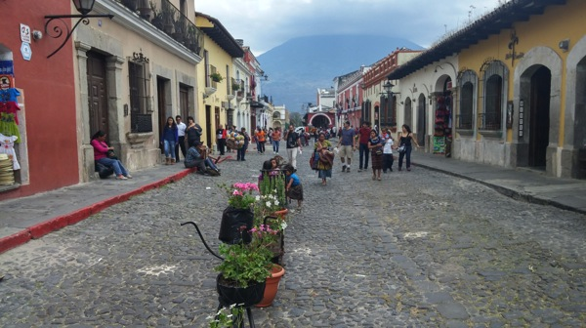

Development Studies: Available Resources in Portland and Beyond

Outside Organizations

While Lewis & Clark has many available resources for students who may be interested in conducting international development research, there are numerous different organizations around Portland that also have a wealth of knowledge about this field. Many of these organizations are also actively engaged in international development projects, and could be useful for finding contacts or relevant projects in the country or countries that you have chosen to study.

An updated, comprehensive list of all of the development organizations in Oregon has been compiled online and can be found here.

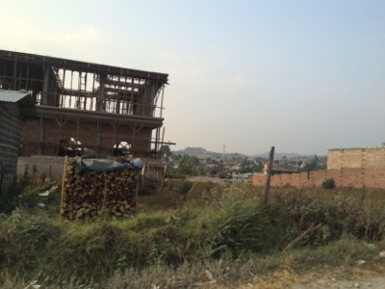
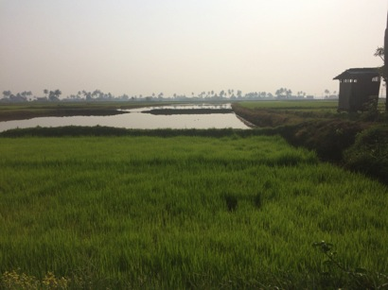

Library Guides (LibGuides)

Library Guides are also a great source of information for development related databases, journal articles, literature reviews, etc. While Watzek is always a great place to start for all your research needs, you may want to consider these LibGuides from Emory University, Brown University, and the National University of Singapore.

Conclusion

Hopefully this guide has served as a sufficient introductory guide to the field of international development work itself, as well as the ins-and-outs of planning research in this field. I was extremely fortunate to have the opportunity to travel multiple times and engage with development issues firsthand, and I hope that more Lewis & Clark students feel compelled to do so in the future. We are entering into an increasingly interconnected age, but we must also be careful to consider both the positive and negative sides of globalization. As international cooperative efforts become more common, it is essential that those who choose to conduct this type of work do so with an educated background and a well-rounded perspective. This guide should make this process a bit easier for you, interested student, and I wish you the very best in all of your international research endeavors.

